**STUDY OF ANALOG, DIGITAL AND MIXED SIGNAL SYSTEM ACROSS DIFFERENT ARCHITECTURE**

**Submitted**

**By**

**VORUGUNTLA MOUNIKA BU21EECE0100376**

**POLIMERA SANDEEP REDDY BU21EECE0100080**

**YERUVA ADITYA UDAYA REDDY BU21EECE0100294**

**Under the Guidance of**

**DR. PRITHVI SHEKAR PAGALA**

**Duration: 15/JULY/2024 to 19/MARCH/2025**



**Department of Electrical, Electronics and Communication Engineering**

**GITAM School of Technology**

**GITAM**

**(DEEMED TO BE UNIVERSITY)**

**(Estd. u/s 3 of the UGC act 1956)**

**NH 207, Nagadenehalli, Doddaballapur taluk, Bengaluru-561203 Karnataka, INDIA.**

**DECLARATION**

**We declare that the project work contained in this report is original and it has been done by me under the guidance of my project guide.**

**Names:**

**V.MOUNIKA**

**P. SANDEEP REDDY**

**Y. ADITYA UDAYA REDDY**

**Date: 19/03/2025**

**Department of Electrical, Electronics and Communication Engineering**

**GITAM School of Technology, Bengaluru-561203**



**CERTIFICATE**

**This is to certify that (Student Name) bearing (Regd. No.:) has satisfactorily completed Mini Project Entitled in partial fulfillment of the requirements as prescribed by University for VIIIth semester, Bachelor of Technology in “Electrical, Electronics and Communication Engineering” and submitted this report during the academic year 2024-2025.**

**Signature of the Guide Signature of HOD**

**Table of contents**

**List of Tables:** 4

**List of Diagrams:** 5

**Chapter 1: Introduction** 6

**1.1 Overview of the problem statement** 6

**1.2 Objectives and goals** 6

**Chapter 2: Literature Review** 7

**Chapter 3: Strategic Analysis and Problem Definition** 8

3**.1 SWOT Analysis** 8

8

**3.2 Project Plan - GANTT Chart** 9

**4.1 Basic Components of Digital Blocks** 10

**4.2 Basic Components of Analog Blocks** 12

**4.3 Basic Components of Mixed signal Blocks** 13

**Chapter 5: Parameters** 14

**5.2 Parameters for each basic component in digital blocks** 16

**5.3 Parameters for each basic component in analog blocks** 17

**5.4 Parameters for each basic component in mixed signal blocks** 18

**Chapter 6: Comparison** 20

**6.1 Comparison Between Analog, Digital, and Mixed Signal Systems** 20

**6.2 Advantages and Disadvantages** 21

**Chapter 7: IMPLEMENTATION TOOL** 24

**Chapter 8: TECHNOLOGIES** 33

**8.1 BJT [BIPOLAR JUNCTION TRANSISTOR]** 33

**8.2 Basic MOSFET** 34

**Chapter 9: Implementation** 38

**9.1 logic gates** 38

**9.2 Flip-Flops (Memory)** 49

**9.3 ALU** 57

**9.4 8-bit RISC processor using Xilinx Vivado** 58

**Chapter 10: Results** 61

**10.1 BJT parameters** 61

**10.2 BASIC MOSFET parameters** 61

**10.3 CMOS parameters** 63

**Chapter 11: Conclusion** 63

**Chapter 12: Future Work** 64

**Chapter 13: References** 64

# **List of Tables:**

|  |  |  |
| --- | --- | --- |
| SL.NO | NAME OF THE TABLE | PAGE NO |
| 1 | Logic Gates | 10 |
| 2 | FlipFlops | 11 |
| 3 | Op-amps | 11 |
| 4 | Mixed signal blocks | 14 |
| 5 | Parameters For Digital Blocks | 16 |
| 6 | Parameters For Analog Blocks | 17-18 |
| 7 | Parameters For Mixed-signal Blocks | 18-19 |
| 8 | Comparison between Digital, Analog, and mixed signal systems | 20-21 |
| 9 | Advantages and Disadvantages of Fundamental Blocks | 21-24 |
| 10 | Logic gates truth tables | 38-42 |
| 11 | Flipflops truth tables | 50-54 |
| 12 | Results for BJT parameters | 61 |
| 13 | Results for Basic MOSFET parameters | 62 |
| 14 | Results for CMOS parameters | 63 |

# **List of Diagrams:**

|  |  |  |
| --- | --- | --- |
| SL.NO | NAME OF THE DAIGRAM | PAGE NO |
| 1 | VLSI design flow | 7 |
| 2 | Cadence Virtuoso | 24-27 |
| 3 | XILINX VIVADO | 29-31 |
| 4 | Logic Gates Symbols | 38-42 |
| 5 | Schematics of Logic Gates | 42-49 |
| 6 | Flip-flops symbols | 49-54 |
| 7 | Flip-flops using Nand Gates | 49-54 |
| 8 | Schematics of Flipflops | 55-57 |
| 9 | RISC schematic | 60 |

# **Chapter 1: Introduction**

## **1.1 Overview of the problem statement**

Understanding the integration and design of multiple signal types within semiconductor devices is essential to the study of digital, Analog, and mixed-signal systems across a variety of VLSI designs. Discrete signals, usually utilizing CMOS technology, define digital systems in VLSI and are crucial for computation and processing. In order to perform tasks like data conversion between digital and Analog forms, mixed-signal systems integrate both digital and Analog components. As a result, they are essential to modern electronics like radio frequency transmission. These systems have different VLSI architectural designs, with Analog circuits prioritizing accuracy and noise reduction and digital circuits emphasizing speed and power efficiency. When using mixed signals. In VLSI architectures, effective data conversion and signal integrity are ensured by reducing interference between digital and Analog components. The advancement of microelectronics depends on the study of these systems because it makes it possible to create integrated circuits that are more effective, small, and adaptable.

## **1.2 Objectives and goals**

Modern electrical design advances greatly from the study of digital, Analog, and mixed-signal systems across many VLSI (Very Large-Scale Integration) architectures. Understanding the guiding ideas and methods for enhancing these systems' functionality, economy of pwer, and spatial use is the main goal. The emphasis is on resilient computation, error correction, and fast data processing through the analysis of digital systems. The study of Analog systems, on the other hand, places more emphasis on precise amplification, minimal noise, and signal quality. The advantages of both are combined in mixed-signal systems, which make it possible to seamlessly integrate digital processing with Analog interfaces a necessary feature for systems like sensor networks and communication systems.

Gaining a comprehensive understanding of these systems is intended to stimulate innovation in VLSI design and pave the way for increasingly complex, efficient, and integrated electronic solutions. Giving engineers the skills and information they need to address the challenges posed by next-generation semiconductor technology is the ultimate aim of this research.

**DESIGN FLOW**

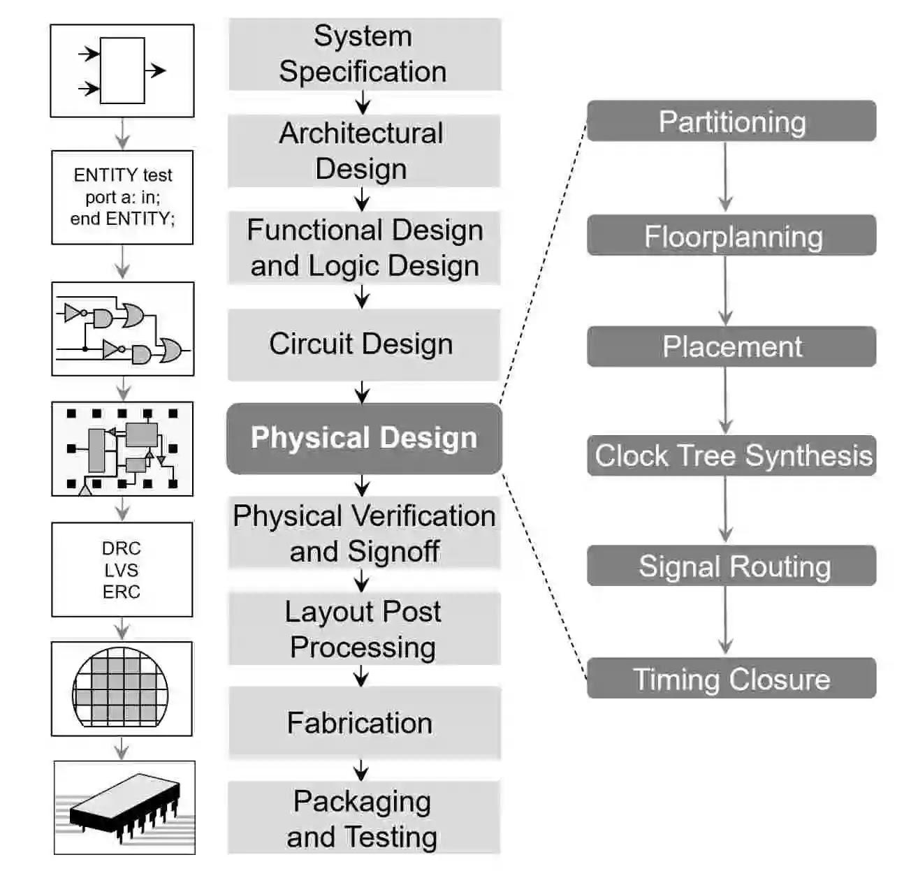

# **Chapter 2: Literature Review**

**Key Publications:**

* VLSI DSP education
* A Mixed-signal Analog-Digital Integrator Design
* A case study of mixed-signal integrated circuit testing: an application of current testing using the upper limit and the lower limit
* A comparative study of advanced mosfet concepts.

**Key Resources:**

* **IEEE(**Institute of Electrical and Electronics Engineers**)**

**References:**

* [**https://ieeexplore.ieee.org/document/409304**](https://ieeexplore.ieee.org/document/409304)
* [**https://ieeexplore.ieee.org/abstract/document/6132448**](https://ieeexplore.ieee.org/abstract/document/6132448)
* [**https://ieeexplore.ieee.org/stamp/stamp.jsp?tp=&arnumber=471669**](https://ieeexplore.ieee.org/stamp/stamp.jsp?tp=&arnumber=471669)
* <https://www.researchgate.net/publication/3062691_A_comparative_study_of_advanced_MOSFET_concepts>

# **Chapter 3: Strategic Analysis and Problem Definition**

## 3**.1 SWOT Analysis**

**VersatileSkillset**: Mastery of multiple signal types broadens problem-solving capabilities.

**System Integration**: Essential for designing and optimizing modern, integrated systems

**Strengths**

**Weaknesses**

**Complexity**: Learning requires deep understanding across diverse domains.

**Resource-Intensive**: Advanced tools and significant time investment needed.

## 

**Threats**

**Rapid Tech Changes**: Knowledge can become outdated quickly.

**Competition**: Field is competitive due to its importance in technology.

**Opportunities**

**High Demand**: Growing need for mixed-signal expertise in various industries.

**Innovation**:Potential to pioneer new, efficient system architectures.

### **3.2 Project Plan - GANTT Chart**

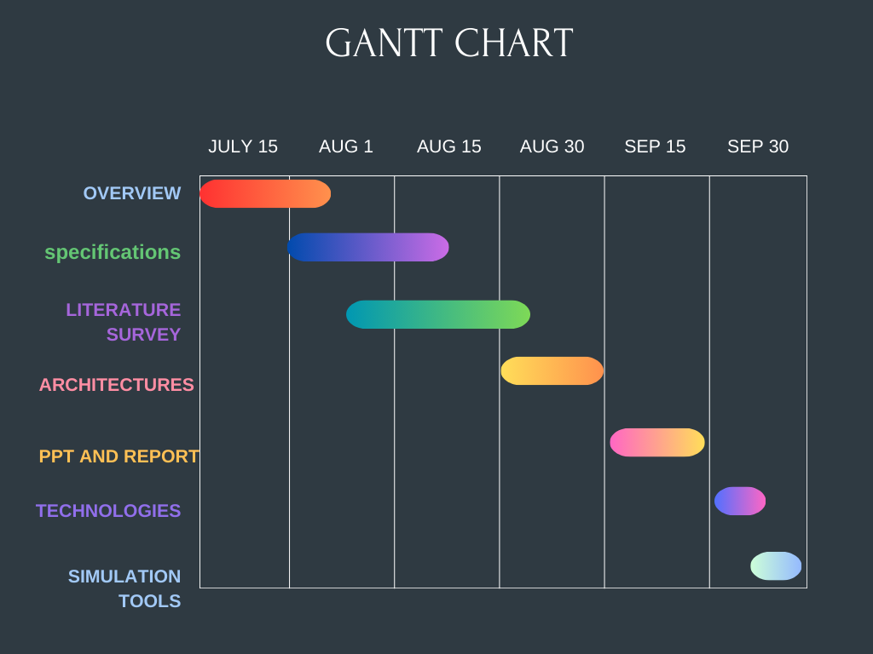

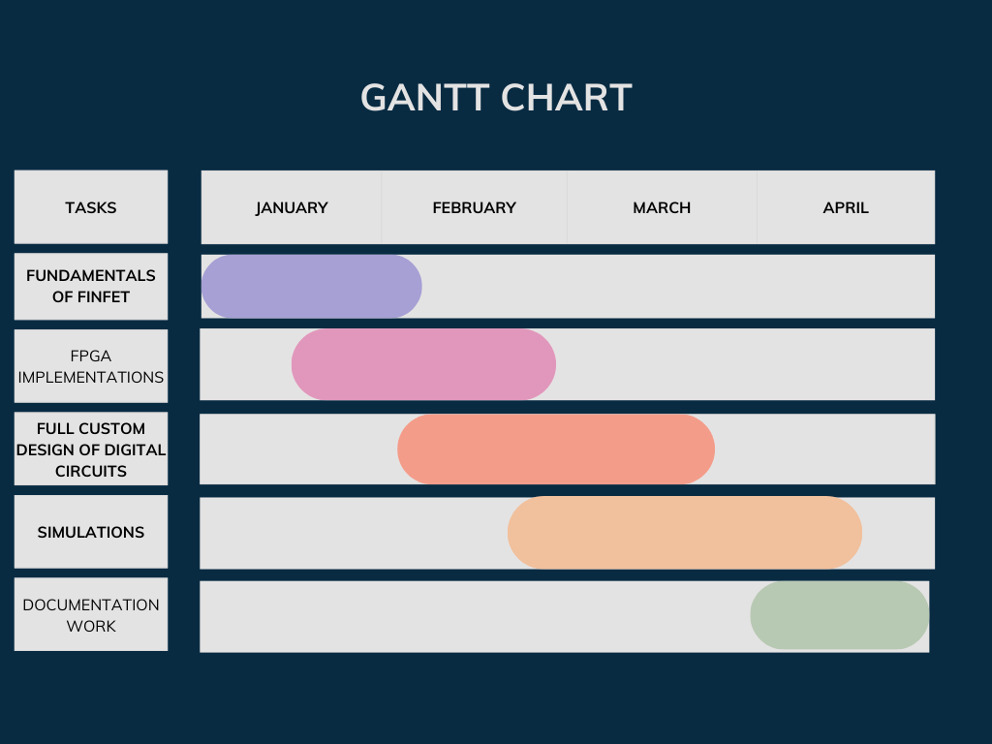

**Chapter 4: Fundamental Blocks**

In VLSI (Very-Large-Scale Integration) design, fundamental blocks are essential elements that form the building blocks of larger systems. These blocks can be categorized into digital, analog, and mixed-signal blocks

## **4.1 Basic Components of Digital Blocks**

* **Logic Gates:** Fundamental building blocks like AND, OR, NOT, NAND, NOR, XOR, and XNOR. These gates form combinational logic circuits, which are essential for performing basic operations in digital circuits.

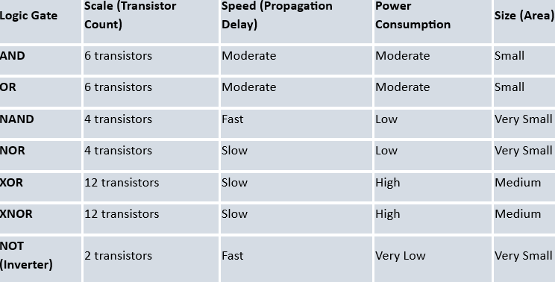

* **Flip-Flops and Latches:** These are used to store binary information (1s and 0s). They are crucial for creating sequential circuits, which rely on a clock signal to change states.

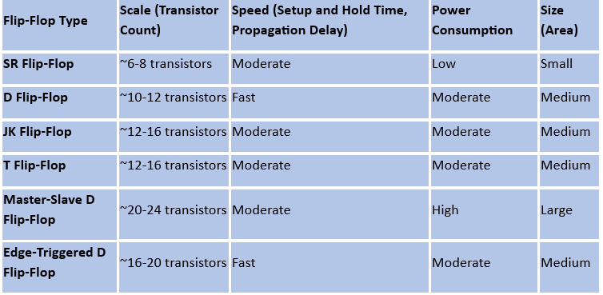

* **Registers:** Group of flip-flops used to store multiple bits of data. They are used in memory units, processors, and data transfer processes.
* **Adders and Subtractors:** Used for arithmetic operations. The most common types are half adders, full adders, and binary subtractors.
* **Multiplexers (MUX) and Demultiplexers (DEMUX):** MUX selects one input from multiple inputs, while DEMUX routes a single input to multiple outputs. They are essential in data routing and control logic.
* **Counters:** Digital blocks used to count events, typically in synchronization with a clock signal. Types include binary counters, up/down counters, and ring counters.

## **4.2 Basic Components of Analog Blocks**

* **Operational Amplifiers (Op-Amps):** Versatile analog circuits used in signal conditioning, filtering, and other analog signal processing tasks. They can perform mathematical operations like addition, subtraction, integration, and differentiation.

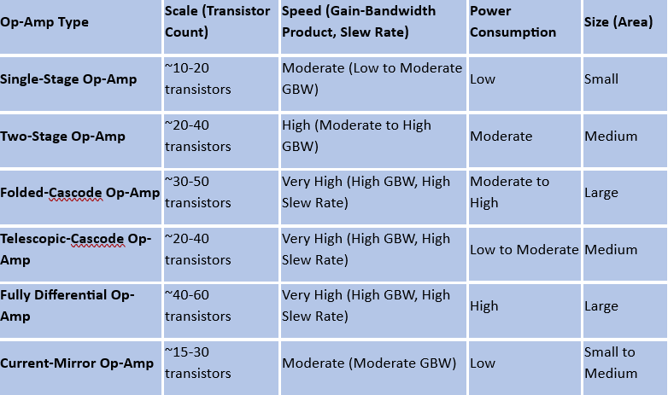

* **Analog Filters:** Circuits that allow certain frequencies to pass while blocking others. Types include low-pass, high-pass, band-pass, and band-stop filters.

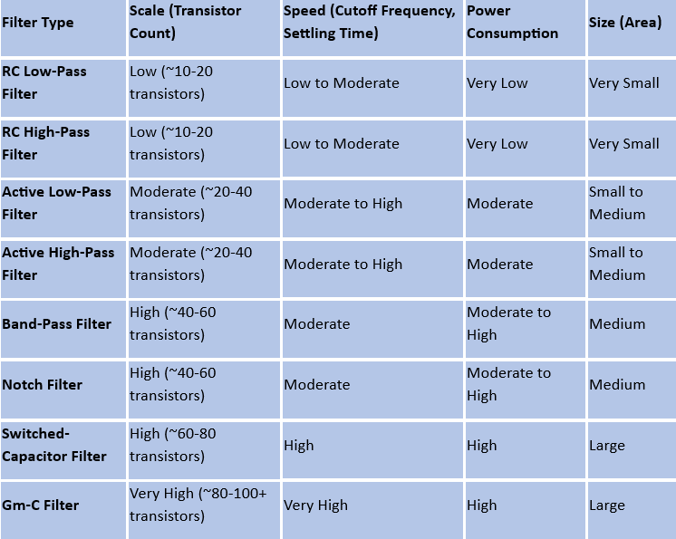

* **Voltage and Current Sources:** Basic components that provide stable voltage or current to other circuits. These include constant voltage sources, constant current sources, and voltage regulators.
* **Analog Multipliers:** Circuits used to multiply two analog signals. They are often used in modulation, demodulation, and frequency mixing applications.
* **Analog-to-Digital Converters (ADC):** Convert continuous analog signals into discrete digital values. ADCs are crucial in systems where analog input signals need to be processed digitally.

#### **4.3 Basic Components of Mixed signal Blocks**

* **Digital-to-Analog Converters (DAC):** Convert digital signals back into analog form. DACs are used in audio playback, video output, and various signal reconstruction tasks.
* **Data Converters (ADC/DAC):** Critical in mixed-signal systems for interfacing analog signals with digital processing units. High-speed, high-precision converters are essential for accurate data conversion.
* **Mixed-Signal Filters:** These filters combine digital and analog filtering techniques. For instance, a digital filter might be used in conjunction with an analog anti-aliasing filter in ADC systems.

| **Parameter** | **Description** | **Impact** |
| --- | --- | --- |
| **Speed** | The maximum operating frequency of the circuit, often determined by the clock rate. | Affects how quickly the circuit can perform operations, impacting overall performance. |
| **Power Consumption** | The amount of power used by the circuit, including static and dynamic power. | Crucial for battery-powered devices; lower power consumption extends battery life and reduces heat. |
| **Area** | The physical size of the circuit, often measured in terms of silicon real estate. | Affects the cost of manufacturing; smaller area allows for more circuits on a single chip. |
| **Delay** | The time taken for a signal to propagate through a circuit from input to output. | Impacts timing and synchronization; lower delay is essential for high-speed circuits. |

# **Chapter 5: Parameters**

**5.1 Parameters for Analog, Digital and Mixed signal blocks**

| **Parameter** | **Analog Blocks** | **Digital Blocks** | **Mixed-Signal Blocks** |
| --- | --- | --- | --- |
| **Signal Type** | Continuous | Discrete (Binary) | Combination of Continuous and Discrete |
| **Voltage Levels** | Multiple levels, often continuous | Two levels (0 and 1) | Both continuous and discrete voltage levels |
| **Power Consumption** | Generally higher, depends on continuous signal processing | Typically lower, depends on logic transitions | Varies; combines analog's higher consumption with digital's lower |
| **Speed** | Lower, limited by analog processing speeds | Higher, determined by clock frequency and logic gates | Moderate; depends on the interfacing between analog and digital blocks |
| **Area** | Larger, requires precision components like capacitors, inductors | Smaller, uses transistors and logic gates | Varies; combining analog and digital components can increase area. |
| **Applications** | Signal amplification, filtering, oscillation, sensor interfacing | Computation, data processing, control logic | ADC/DAC, communication systems, sensor integration, power management |
|  |  |  |  |
|  |  |  |  |
|  |  |  |  |
|  |  |  |  |
|  |  |  |  |
|  |  |  |  |
|  |  |  |  |
|  |  |  |  |

## **5.2 Parameters for each basic component in digital blocks**

| **Parameter** | **Logic Gates** | **Combinational Circuits** | **Sequential Circuits** | **ALU (Arithmetic Logic Unit)** | **Memory Blocks** |
| --- | --- | --- | --- | --- | --- |
| **Performance** | Basic, performs simple logic operations | Intermediate, performs complex logic operations | Advanced, supports state-based operations | High, performs arithmetic and logical functions | Varies; high performance in data storage/retrieval |
| **Design Complexity** | Low, simple design with basic logic elements | Moderate, requires more gates and connections | High, involves feedback and timing considerations | High, combines multiple operations into one unit | High, involves intricate cell design and architecture |
| **Speed** | Very High, depends on the propagation delay | High, depends on the circuit depth and fan-out | Moderate to Low, limited by clock frequency | High, optimized for fast arithmetic operations | Varies, depends on access time and architecture |
| **Area** | Small, requires minimal chip area | Larger, increases with circuit complexity | Large, requires additional storage elements like flip-flops | Large, integrates multiple functional units | Large, especially in high-density memory arrays |
| **Delay** | Minimal, limited to gate propagation delay | Low to Moderate, accumulates with gate levels | Moderate to High, depends on clock cycles | Moderate, delay depends on operation complexity | Varies, access time depends on type (SRAM, DRAM) |
| **Power Consumption** | Low, due to simple operation and fewer transistors | Moderate, more gates lead to higher power usage | High, due to clocking and state retention | High, due to high activity and operation density | High, particularly in dynamic memories (DRAM) |
|  |  |  |  |  |  |
| **Application Examples** | AND, OR, NOT gates in basic logic operations | Adders, Multiplexers, Decoders, Encoders | Counters, Registers, Flip-Flops | Microprocessor ALUs, Digital Signal Processing units | RAM, ROM, Cache memory blocks |

## **5.3 Parameters for each basic component in analog blocks**

| **Parameter** | **Op-Amps** | **Analog Filters** | **Oscillators** | **Voltage & Current Sources** | **Analog Multipliers** |
| --- | --- | --- | --- | --- | --- |
| **Performance** | High gain, high input impedance, low output impedance | Selectivity, insertion loss, filter order | Frequency stability, low phase noise | Precision, stability, low output noise | Linearity, bandwidth, low distortion |
| **Design Complexity** | Moderate to high; depends on required precision and stability | Varies; higher-order filters are more complex | Moderate; depends on desired frequency accuracy | Moderate to high; requires precision components | High; involves nonlinear components and feedback |
| **Speed** | Moderate; depends on bandwidth and slew rate | Varies; higher cutoff frequency filters are faster | High; depends on frequency range | Generally low; DC or low-frequency operation | Moderate; limited by response time and bandwidth |
| **Noise** | Low noise design required for high precision | Low noise desired; varies by filter type | Low to moderate; phase noise is critical | Low noise critical, especially for voltage references | Moderate; noise impacts accuracy in signal processing |
| **Area** | Moderate; depends on the number of stages and compensation | Moderate; depends on filter order and topology | Small to moderate; depends on resonator type | Small to moderate; depends on precision requirements | Moderate; area depends on the complexity of the circuit |
| **Delay** | Minimal; primarily influenced by bandwidth | Dependent on filter type (e.g., FIR, IIR) | Low; usually negligible in steady-state operation | Negligible; primary delay in feedback regulation | Moderate; delay can affect signal processing accuracy |

## **5.4 Parameters for each basic component in mixed signal blocks**

| **Parameter** | **Analog-to-Digital Converters (ADCs)** | **Digital-to-Analog Converters (DACs)** | **Phase-Locked Loops (PLLs)** | **Mixed-Signal Filters** | **Voltage References** |
| --- | --- | --- | --- | --- | --- |
| **Performance** | High accuracy, resolution, SNR, and linearity | High resolution, low distortion | High frequency stability and low jitter | High selectivity, low distortion | High stability, low temperature drift |
| **Design Complexity** | High; involves precise analog and digital integration | Moderate; less complex than ADCs | High; requires precise control of analog and digital parts | High; combines analog and digital filtering | Moderate; requires stable reference generation |
| **Speed** | Varies; high-speed ADCs can reach several Gsps | Varies; high-speed DACs up to several Gsps | High; PLLs can operate in the GHz range | Moderate; depends on filter type and application | Moderate; needs to respond quickly to load changes |
| **Noise** | Susceptible to thermal noise, quantization noise | Susceptible to noise and distortion | Sensitive to phase noise, jitter | Moderate; noise impacts overall signal quality | Low; designed to minimize output noise |
| **Area** | Large; depends on resolution and architecture | Large; depends on resolution and architecture | Moderate; compact but requires precise layout | Moderate to large; area depends on complexity | Small; typically occupies minimal area |
| **Delay** | Moderate to high; depends on conversion time and sampling rate | Low to moderate; depends on architecture | Low; fast phase locking is critical | Low to moderate; depends on filter design | Very low; needs to provide stable voltage quickly |

# **Chapter 6: Comparison**

### **6.1 Comparison Between Analog, Digital, and Mixed Signal Systems**

| **Aspect** | **Analog Systems** | **Digital Systems** | **Mixed-Signal Systems** |
| --- | --- | --- | --- |
| **Signal Type** | Continuous signals | Discrete signals (binary) | Combination of continuous and discrete signals |
| **Design Approach** | Focus on continuous signal processing with precise analog components. | Focus on logic gates and sequential circuits with discrete operations. | Integration of both analog and digital components, requiring a combination of design methodologies. |
| **Performance Metrics** | Gain, bandwidth, noise figure, linearity | Speed, power consumption, area, timing | Signal-to-noise ratio (SNR), total harmonic distortion (THD), conversion speed |
| **Power Consumption** | Generally higher; depends on continuous signal processing. | Typically lower; depends on switching activity. | Varies; combines analog’s higher consumption with digital’s lower consumption. |
| **Speed** | Generally lower; limited by analog processing speeds. | Generally higher; limited by clock frequency and logic gates. | Moderate; depends on the interface between analog and digital components. |
| **Area** | Larger; requires space for analog components like capacitors and inductors. | Smaller; uses compact transistors and logic gates. | Varies; combining analog and digital components can increase area. |
| **Noise Sensitivity** | High; affected by thermal, flicker, and phase noise. | Low; more immune to noise due to discrete nature. | Moderate; requires careful design to manage noise in both domains. |
| **Design Complexity** | High; requires precise component matching and layout. | Lower; focused on logic design and timing. | High; integration of analog and digital components increases complexity. |
| **Testing and Verification** | Challenging; specialized techniques for measurement and verification. | Easier; can use standard logic testers and simulation. | Complex; needs both analog and digital testing approaches. |
| **Simulation Tools** | SPICE, Cadence Spectre, Mentor Graphics Eldo. | ModelSim, Synopsys VCS, Xilinx Vivado. | Cadence AMS, Mentor HyperLynx. |
| **Implementation Tools** | Cadence Virtuoso, Mentor Calibre, Analog Layout Tools. | Cadence Innovus, Synopsys IC Compiler, Digital Layout Tools. | Cadence Virtuoso for layout, Synopsys IC Compiler for digital integration. |
| **Typical Applications** | Analog filters, amplifiers, oscillators, sensors. | Microprocessors, memory, digital communication systems. | ADCs/DACs, communication systems, sensor interfaces, power management. |

### **6.2 Advantages and Disadvantages**

**Advantages**:

| **System Type** | **Advantages** |
| --- | --- |
| **Analog Systems** | - **High Resolution**: Analog systems can process signals with very fine resolution, useful for precise measurements and high-fidelity applications.  - **Continuous Signals**: Capable of handling continuous signals and maintaining signal quality with minimal distortion.  - **Real-Time Processing**: Effective for real-time processing tasks where continuous signal processing is required, such as audio and RF systems.  - **Low Power for Simple Tasks**: In some cases, analog circuits can be more power-efficient for specific tasks compared to digital circuits. |
| **Digital Systems** | - **Noise Immunity**: Digital systems are less affected by noise and signal degradation, which makes them reliable for data transmission and processing.  - **Ease of Design and Debugging**: Digital design tools and methodologies simplify design and debugging processes, with well-established verification techniques.  - **Scalability**: Digital systems can be scaled down to smaller technology nodes, allowing for high-density integration and better performance.  - **Flexibility**: Digital systems can be easily reprogrammed or modified, offering high versatility for various applications.  - **Power Efficiency for Complex Operations**: Digital circuits often consume less power for complex calculations compared to analog systems. |
| **Mixed-Signal Systems** | - **Versatility**: Combines the best features of both analog and digital systems, allowing for a wide range of applications including analog-to-digital conversion and signal processing.  - **Integration**: Allows integration of analog and digital functions on a single chip, reducing the need for external components and minimizing system size and cost.  - **Improved Performance**: Enhances system performance by leveraging analog precision for signal acquisition and digital processing for computation and control.  - **Cost and Space Efficiency**: Reduces overall system cost and board space by combining both analog and digital functions into one chip.  - **Better System Coordination**: Facilitates more seamless interaction between analog and digital domains, improving system-level coordination and efficiency. |

**Disadvantages:**

| **System Type** | **Disadvantages** |
| --- | --- |
| **Analog Systems** | - **Noise Sensitivity**: Analog circuits are more susceptible to noise and interference, affecting performance and accuracy. - **Design Complexity**: Requires precise component matching and careful layout. - **Temperature Variability**: Analog performance can vary with temperature changes. - **Nonlinearity**: Analog components can exhibit nonlinear behavior, complicating design. - **Scaling Limitations**: Analog circuits do not scale as effectively with technology advancements as digital circuits. |
| **Digital Systems** | - **Power Consumption**: Digital circuits can consume significant power, especially at high speeds. - **Area**: High-density digital designs can occupy a large area on the chip. - **Design Complexity**: Large digital systems can be complex to design, particularly with advanced features. - **Speed Limitations**: Performance is limited by clock speed and propagation delays. - **Testing Challenges**: Ensuring correct functionality and timing can be difficult, requiring extensive testing and verification. |
| **Mixed-Signal Systems** | - **Design Complexity**: Integrating both analog and digital components increases design complexity and challenges. - **Signal Integrity Issues**: Managing signal integrity across analog and digital boundaries can be difficult. - **Power Management**: Mixed-signal systems often require careful power management due to differing power needs of analog and digital components. - **Layout Challenges**: Physical layout must address both analog and digital requirements, complicating the design. - **Cost**: Mixed-signal designs can be more expensive to develop and manufacture due to the need for specialized design tools and processes. |

# **Chapter 7: IMPLEMENTATION TOOL**

**7.1 Cadence Virtuoso**

Cadence Virtuoso is widely used for **custom IC design**, including **schematic entry, layout, and simulation**.

STEPS:

1. Open VirtualBox and start the Linux OS where Cadence Virtuoso 7.1 is installed.

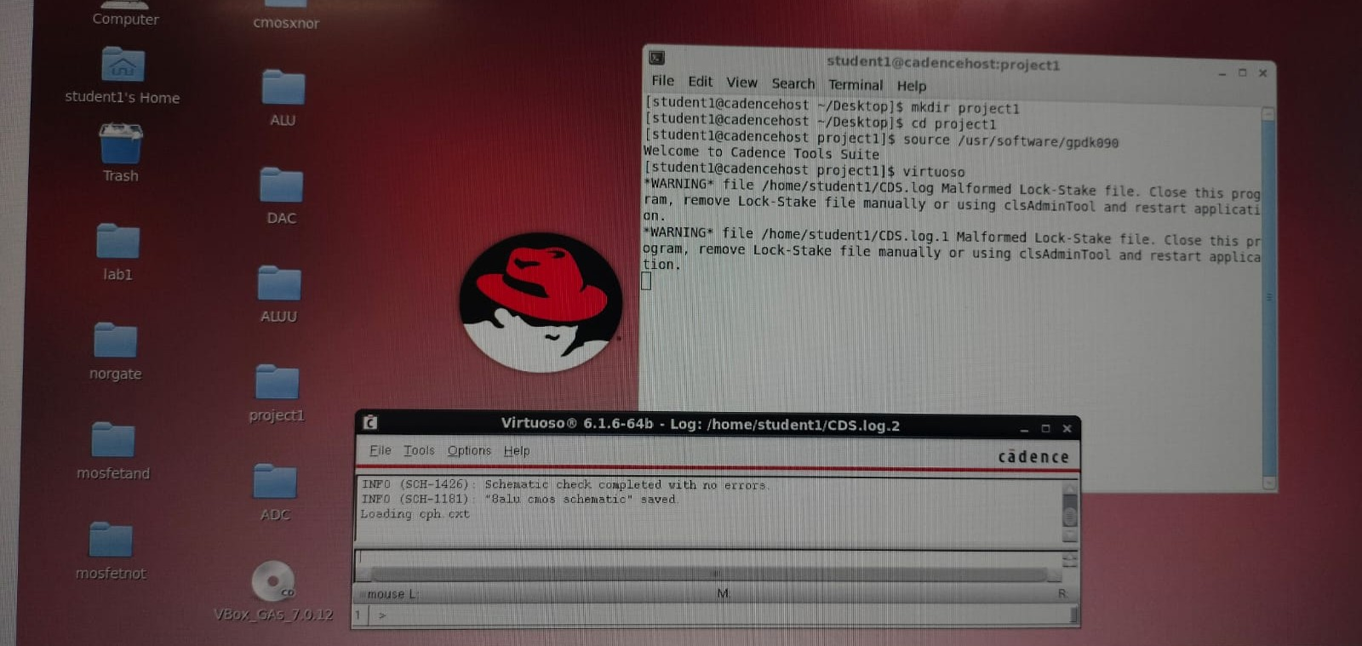

1. Open a terminal and start Cadence using the command:

MKDIR → File name.

CD → file name.

PWD

SOURCE /USR/SOFTWARE/GPDK090

VIRTUOSO&

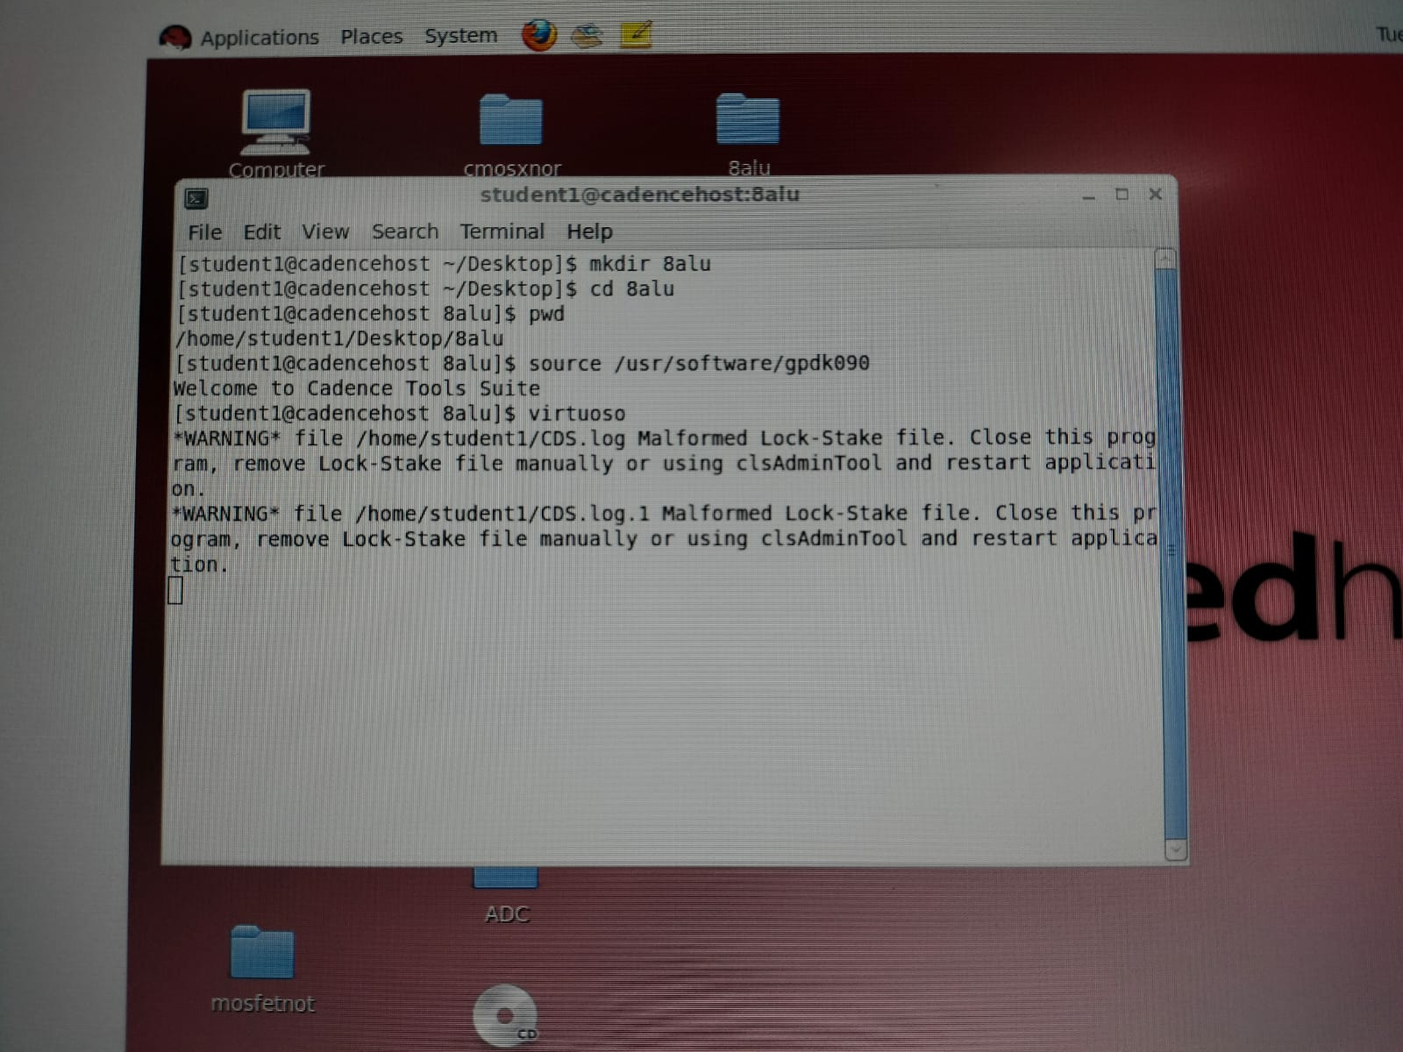

**2. Create a New Library**

1. In the **CIW window**, go to **Tools → Library Manager**.
2. Click **File → New → Library**.
3. Enter a **Library Name** (e.g., "MyDesign").
4. Select **Attach to existing technology file**, then choose the **technology (e.g., CMOS 180nm, 45nm)**.
5. Click **OK**.

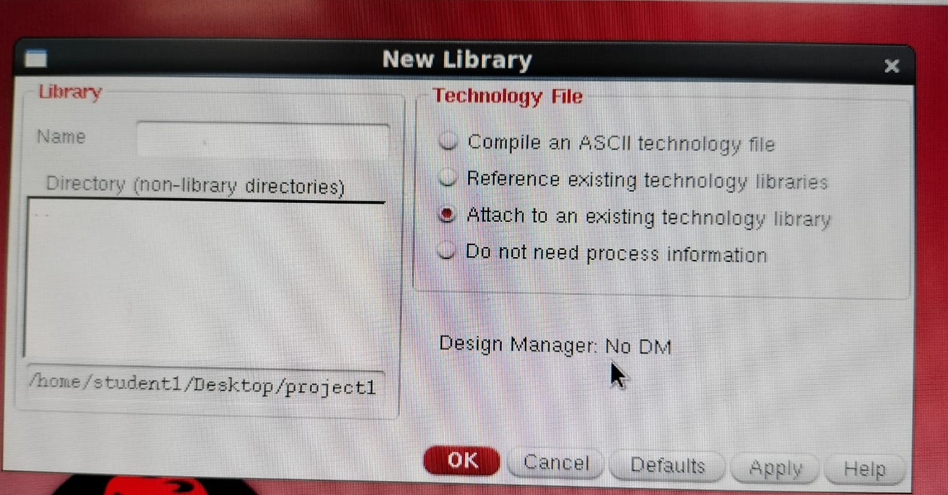

**3. Create a New Schematic Cell**

1. In **Library Manager**, select your new library (**MyDesign**).
2. Click **File → New → Cell View**.
3. Set:
   * **Cell Name:** (e.g., "Inverter")
   * **View Name:** "schematic"
   * **Tool:** "Composer-Schematic"
4. Click **OK**.
   * This opens the **Virtuoso Schematic Editor** window.

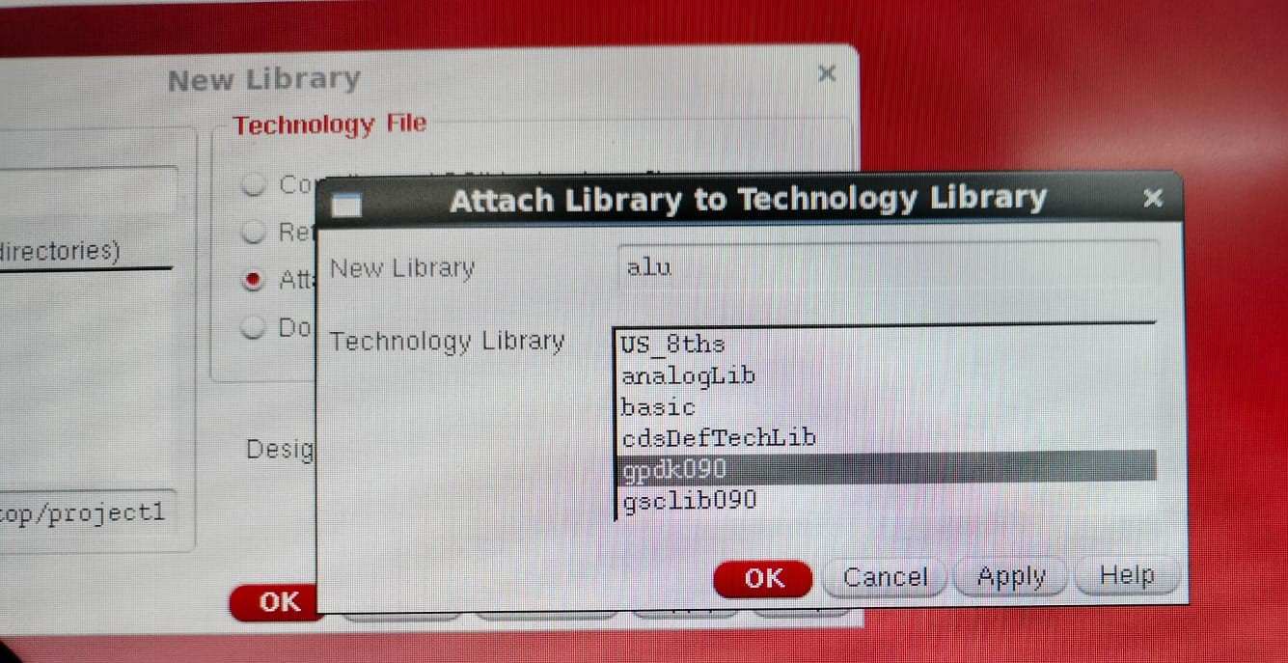

**4. Add Components to Schematic**

1. Click **Create → Instance** (or press i).
2. In the **Add Instance** window:
   * Click **Browse** to open the **Library Manager**.
   * Select the library (e.g., "analogLib" for basic components).
   * Choose components like **nMOS, pMOS, VDD, GND, input sources**.
   * Click **Close** to return to the schematic.
3. **Place the components** in the schematic editor by clicking in the workspace.

**5. Connect Components with Wires**

1. Click **Create → Wire (narrow)** (or press w).
2. Click on a **component terminal** and drag to connect it to another terminal.
3. Ensure all connections are correctly made.

**6. Add Input & Output Pins**

1. Click **Create → Pin**.
2. Enter the pin name (e.g., VIN, VOUT).
3. Select **Direction** (e.g., **Input, Output, or Bidirectional**).
4. Click **OK** and place the pins on the schematic.

**7. Check & Save the Schematic**

1. Click **Check & Save** (or press Shift + X).
2. If there are **errors**, fix them before proceeding.

**8. Simulate the Schematic using ADE**

1. Open **Tools → Analog Design Environment (ADE L)**.
2. Click **Setup → Simulator/Directory/Host** and choose **Spectre**.
3. Click **Analyses → Choose**, then select **Transient Analysis (tran)**.
4. Click **Run** to simulate the circuit.
5. View the **waveforms** using the **Results Browser**.

**7.2 XILINX VIVADO**

Xilinx Vivado is a tool for FPGA design, synthesis, simulation, and implementation. Xilinx Vivado 2016.2 is an older but widely used version of the **FPGA development tool** for designing, simulating, and implementing **digital circuits on Xilinx FPGAs**.

STEPS:

* + **Open Vivado 2016.2** and click **"Create New Project"**.

**Project Setup:**

* **Project Name:** (e.g., FPGA_Project)
* **Project Location:** Choose a working directory.
* **Project Type:** Select **RTL Project**.
* **Add Sources:** Skip for now (we will add later).
* **Choose FPGA Part:** Select the target FPGA (e.g., **XC7A35T-1FTG256** for Artix-7).
* Click **Finish** to create the project.

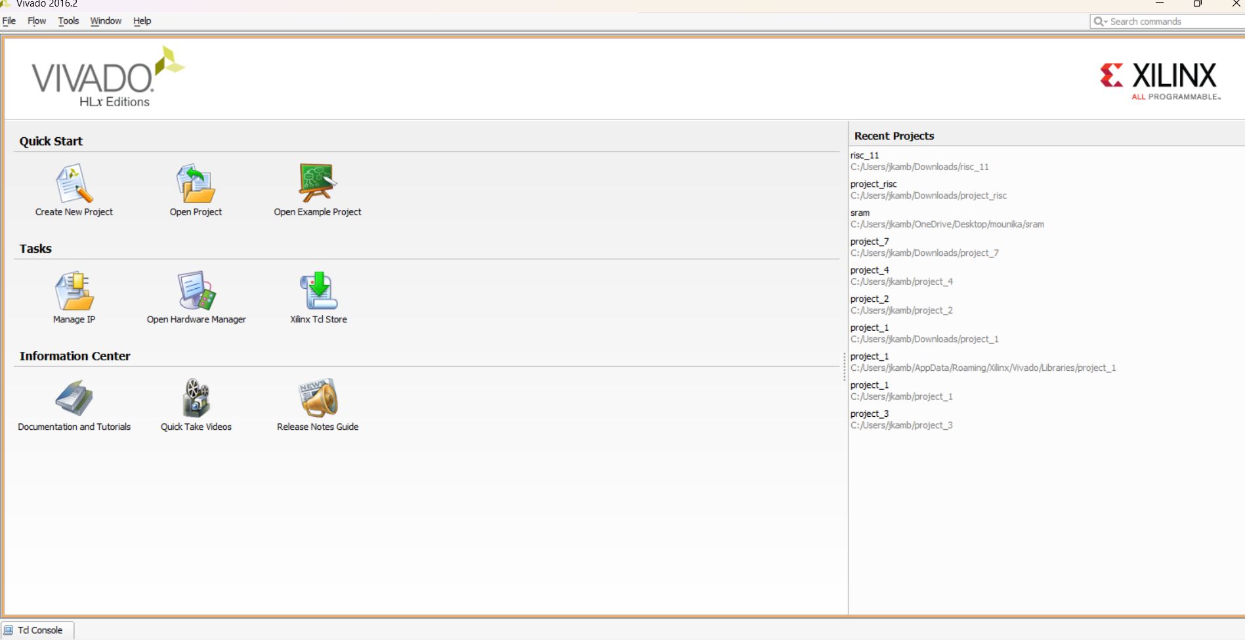

Adding Verilog/VHDL Source Code

* **In the Vivado project window**, go to **Project Manager → Add Sources**.
* Select **"Add or Create Design Sources"** → Click **Next**.
* Click **"Create File"**, choose **Verilog** or **VHDL**, and enter the filename (e.g., inverter.v).
* Click **Save**.

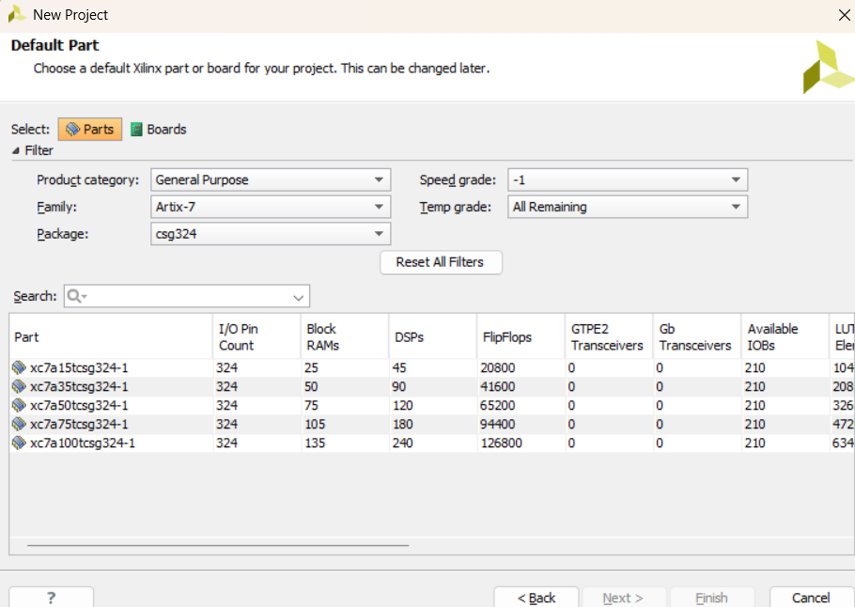

Running Simulation in Vivado 2016.2

1. In the **Flow Navigator**, go to **Simulation → Run Simulation → Run Behavioral Simulation**.
2. The Vivado Simulator will open, showing **waveforms** of A and Y.
3. Adjust the **timing and signals** if needed.

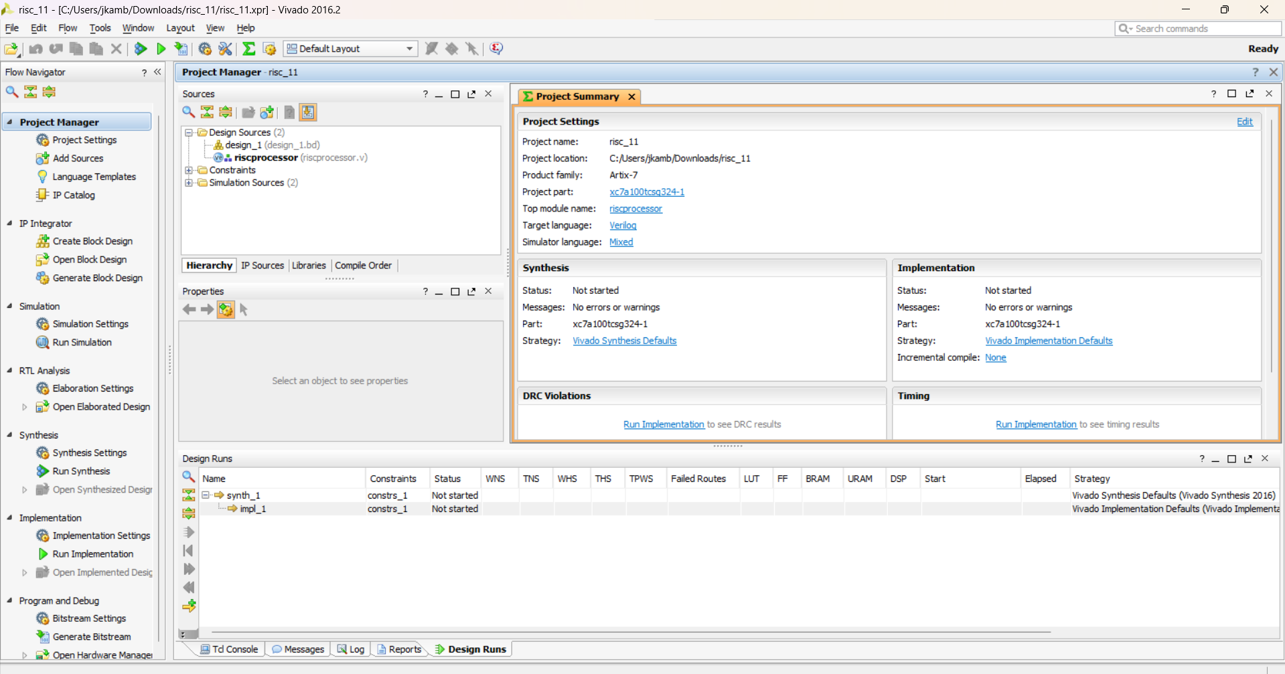

Synthesizing the Design

1. Click **Run Synthesis** in **Flow Navigator**.
2. Check the **Synthesis Report** for errors/warnings.
3. If successful, proceed to **Implementation**.

Implementing & Generating Bitstream

1. Click **Run Implementation** to map the design to FPGA resources.
2. Click **Generate Bitstream** to create a **.bit file** for FPGA programming.
3. If a constraints file is required, add an **XDC file** (Pin Mapping).

Uploading Bitstream to FPGA Board

1. Connect the FPGA board via **JTAG USB cable**.
2. In Vivado, open **Hardware Manager** → Click **Open Target** → **Auto Connect**.
3. Select the **.bit file** and program the FPGA.

**7.3 Comparison between cadence virtuoso and Xilinx VIVADO for Schematic Design.**

Both Cadence Virtuoso and Xilinx Vivado are powerful tools used in VLSI and FPGA design, but they have different use cases when it comes to schematic design.

1. Cadence Virtuoso (Used in ASIC/Custom IC Design)

✅ Advantages:

1. Analog & Mixed-Signal Design
   * Best suited for custom IC design (Analog, Mixed-signal, RF circuits).
   * Provides advanced SPICE simulations using Spectre/APS.
2. Transistor-Level Design
   * Allows direct MOSFET-level schematic entry for custom circuit design.
   * Supports custom layout generation from schematics (SKILL scripting).
3. Seamless Integration with Layout
   * Supports schematic-driven layout (SDL) for physical design.
   * Layout tools like Virtuoso Layout XL allow quick floorplanning.
4. Accurate Parasitic Extraction (PEX)
   * Helps analyze parasitic effects at the transistor level for high-speed designs.
5. Industry Standard for Custom ICs
   * Used in foundries and top semiconductor companies for chip design.

❌ Disadvantages:

1. Not Suitable for FPGA Design
   * Designed for ASIC and custom IC design, not for FPGA programming.
2. Complex Learning Curve
   * Requires expertise in SPICE simulations, layout design, and foundry-specific PDKs.
3. Expensive Licensing
   * Requires a paid license (not available as a free tool).
4. Limited Digital Design Capabilities
   * Not optimized for large-scale RTL-based digital logic design like FPGA tools.

2. Xilinx Vivado (Used in FPGA/HDL-Based Design)

✅ Advantages:

1. Ideal for Digital Logic Design
   * Best for designing FPGA-based digital circuits using schematic or HDL (Verilog/VHDL).
2. Predefined IP Blocks
   * Provides IP cores, DSP blocks, AXI interfaces, making digital design faster.
3. Built-in Synthesis & Simulation
   * Includes Vivado Synthesis and Simulation Engine (no need for external SPICE simulators).
4. Free WebPACK Version
   * Offers a free version (Vivado WebPACK) for entry-level FPGA design.
5. Better for RTL Design Flow
   * Supports behavioral, RTL, and gate-level simulation with Xilinx IP integration.

❌ Disadvantages:

1. Not Suitable for Custom Analog Design
   * Lacks analog transistor-level design support (unlike Cadence Virtuoso).
2. Limited to Xilinx FPGAs
   * Only works with Xilinx FPGA families (Artix, Zynq, Kintex, etc.).
3. Lacks Foundry-Specific PDKs
   * Cannot be used for ASIC fabrication like Cadence Virtuoso.

# **Chapter 8: TECHNOLOGIES**

# **8.1 BJT [BIPOLAR JUNCTION TRANSISTOR]**

Bipolar Junction Transistor (BJT) technology has played a crucial role in the development of VLSI (Very Large Scale Integration) circuits, particularly in high-speed, high-frequency, and analog applications. While MOSFETs dominate modern VLSI due to their low power consumption and high integration capability, BJTs are still used in niche applications where their advantages in speed and gain are needed.

**Introduction to BJT Technology**

A Bipolar Junction Transistor (BJT) is a three-terminal semiconductor device that operates based on both electron and hole charge carriers, making it a bipolar device. It consists of three regions:

1. Emitter (E) – Heavily doped to inject charge carriers.
2. Base (B) – Thin and lightly doped to allow charge carrier diffusion.
3. Collector (C) – Moderately doped and larger to collect charge carriers.

BJTs can be classified into:

* NPN BJTs (Majority carriers are electrons)
* PNP BJTs (Majority carriers are holes)

**BJT in VLSI Technology**

BJTs were used in early VLSI technology before the rise of CMOS. They are still used in high-performance BiCMOS (Bipolar-CMOS) processes. Some areas where BJTs are relevant include:

* Analog circuits (e.g., op-amps, amplifiers)
* High-speed digital circuits
* RF and microwave circuits
* Power electronics
* Memory technologies (e.g., ECL - Emitter Coupled Logic)

# **8.2 Basic MOSFET**

MOSFET (**Metal-Oxide-Semiconductor Field-Effect Transistor**) is the fundamental building block of modern VLSI circuits. It is widely used due to its **low power consumption, high integration capability, and scalability**.

**Introduction to MOSFET**

MOSFET is a three-terminal or four-terminal device that controls the flow of current using an electric field. The three main terminals are:

* Gate (G) – Controls the transistor operation.
* Source (S) – Provides charge carriers (electrons or holes).
* Drain (D) – Collects charge carriers from the source.
* Body (B) (optional) – Can be connected to source or a separate bias voltage.

Types of MOSFETs

MOSFETs can be classified based on channel type and mode of operation:

1. Based on Channel Type:
   * nMOS (n-channel MOSFET) – Electrons as majority carriers.
   * pMOS (p-channel MOSFET) – Holes as majority carriers.
2. Based on Operation Mode:
   * Enhancement Mode – Normally OFF, requires a voltage to turn ON.
   * Depletion Mode – Normally ON, requires a voltage to turn OFF.

**MOSFET Operation**

NMOS Operation (Enhancement Mode)

* When V_GS = 0V, no current flows (OFF state).
* When V_GS > V_th (threshold voltage), an inversion layer (n-type channel) is formed, allowing current to flow between Drain and Source (ON state).
* Increasing V_DS further enhances current flow.

PMOS Operation (Enhancement Mode)

* When V_GS = 0V, the transistor is ON (since pMOS conducts when negative voltage is applied).
* When V_GS < V_th, the transistor turns OFF.

NMOS is preferred over pMOS because:  
✅ Higher mobility of electrons than holes → Faster operation.  
✅ Lower resistance → Better performance in digital circuits.

**MOSFET Characteristics & Regions of Operation**

MOSFET Regions of Operation

1. Cutoff Region (OFF State)
   * V_GS < V_th
   * No channel is formed → No current flow.
2. Linear Region (Triode/Ohmic Mode)
   * V_GS > V_th and V_DS is small
   * Acts as a variable resistor.
   * Used in analog applications like amplifiers.
3. Saturation Region (Active Mode)
   * V_GS > V_th and V_DS > V_GS - V_th
   * MOSFET is fully ON, allowing maximum current flow.
   * Used in digital switching applications.

**MOSFET in VLSI Technology**

MOSFETs are the primary choice in VLSI circuits due to:  
✅ Scalability – Smaller transistors enable more components per chip.  
✅ Low power consumption – Unlike BJTs, MOSFETs consume negligible static power.  
✅ High speed – Suitable for GHz range applications.  
✅ High integration density – Essential for microprocessors and memory chips.

**MOSFET Scaling in VLSI**

**Moore’s Law & Scaling**

* **Moore's Law** states that transistor density doubles approximately every **2 years**.
* Scaling MOSFETs increases **performance and integration**, but leads to new challenges:  
  🔴 Short-channel effects (SCEs)  
  🔴 Increased leakage current  
  🔴 Higher power density.

**8.3 CMOS**

**Introduction to CMOS**

CMOS (**Complementary Metal-Oxide-Semiconductor**) is the dominant technology in **VLSI (Very Large-Scale Integration)** due to its **low power consumption, high noise immunity, and scalability**. It is the foundation for **microprocessors, memory chips, FPGAs, and ASICs**.

CMOS technology uses **both nMOS and pMOS transistors** in a **complementary manner** to implement logic circuits with minimal power dissipation.

**Structure of CMOS**

A **CMOS circuit** consists of:

* **nMOS Transistor:** Turns ON when **V_GS > V_th**, allowing current from drain to source.
* **pMOS Transistor:** Turns ON when **V_GS < V_th**, allowing current from source to drain.
* **Complementary Design:** Ensures low static power dissipation.

**Basic CMOS Inverter Structure:**

* **pMOS** at the top (connected to VDD)
* **nMOS** at the bottom (connected to GND)
* **Input (VIN):** Controls the gate of both transistors.
* **Output (VOUT):** Taken at the common connection of the two transistors.

✅ **Logic Operation:**

| **Input (VIN)** | **PMOS** | **NMOS** | **Output (VOUT)** |
| --- | --- | --- | --- |
| **0 (LOW)** | ON | OFF | **1 (HIGH)** |
| **1 (HIGH)** | OFF | ON | **0 (LOW)** |

**Advantages of CMOS**

✅ **Low Power Consumption** – Power is only consumed during switching.  
✅ **High Noise Immunity** – Can tolerate fluctuations in input signals.  
✅ **Scalability** – Supports Moore’s Law (higher transistor density).  
✅ **High Speed** – Used in GHz-range processors and high-speed logic.  
✅ **Wide Operating Voltage Range** – Suitable for both low-power and high-performance applications.

**CMOS Logic Gates**

Using **CMOS logic**, various gates are implemented by combining **nMOS and pMOS** transistors.

**CMOS Inverter (NOT Gate)**

* **Simple CMOS structure** with **one pMOS and one nMOS**.
* Consumes power only during transitions.

**NAND and NOR Gates**

* **NAND Gate** → nMOS in **series**, pMOS in **parallel**.
* **NOR Gate** → nMOS in **parallel**, pMOS in **series**.
* NAND is preferred in VLSI since it is more efficient.

**XOR and XNOR Gates**

* Built using a combination of NAND, NOR, and NOT gates.
* Used in **adders, parity checkers, and error detection** circuits.

**CMOS Power Dissipation**

Power consumption in CMOS comes from three components:

1. **Static Power (Leakage Current)**
   * Ideally **zero** but increases with **scaling** due to leakage currents.
2. **Dynamic Power (Switching Loss)**
   * Power consumed when transistors switch states.
   * Given by: Pdynamic=CLVDD2fP_{dynamic} = C_L V_{DD}^2 fPdynamic​=CL​VDD2​f
   * **Reducing VDD and capacitance** minimizes dynamic power.
3. **Short-Circuit Power**
   * A brief current spike when both nMOS and pMOS conduct during switching.

**CMOS Scaling**

**Moore’s Law & Miniaturization**

* Transistor density doubles every ~2 years.
* Improves speed, power efficiency, and cost per transistor.

# **Chapter 9: Implementation**

# **9.1 logic gates**

Logic gates are the fundamental building blocks of digital circuits. They perform basic logical functions that are essential for digital computation. Each gate follows a specific logical operation and produces an output based on given inputs.

**NOT GATE:**

**Symbol:**

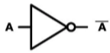

**Operation:** **Inverts** the input (0 becomes 1, 1 becomes 0).

**Truth Table:**

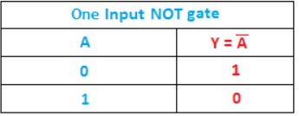

**AND GATE:**

**Symbol:**

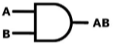

**Operation:** Output is **HIGH (1)** only if **both inputs** are HIGH

**Truth Table:**

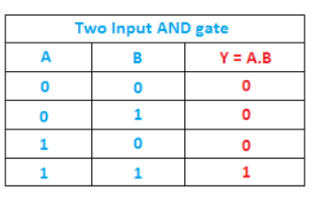

**OR GATE:**

**Symbol:**

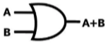

**Operation:** Output is **HIGH (1)** if **at least one input** is HIGH.

**Truth Table:**

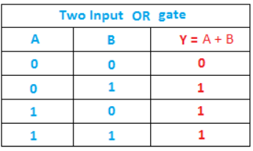

**NAND GATE:**

**Symbol:**

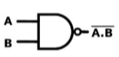

**Operation:** Inverse of AND gate (Output is LOW only if both inputs are HIGH).

**Truth Table:**

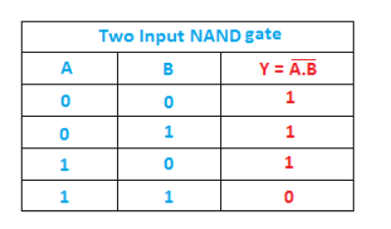

**NOR GATE:**

**Symbol:**

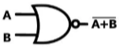

**Operation:** Inverse of OR gate (Output is HIGH only if both inputs are LOW).

**Truth Table:**

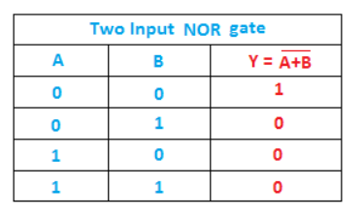

**X-OR GATE:**

**Symbol:**

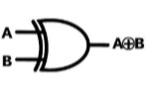

**Operation:** Output is HIGH when inputs are different.

**Truth Table:**

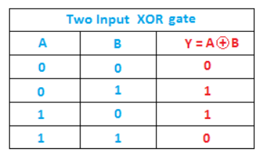

**X-NOR GATE:**

**Symbol:**



**Operation:** Inverse of XOR (Output is HIGH when inputs are the same).

**Truth Table:**

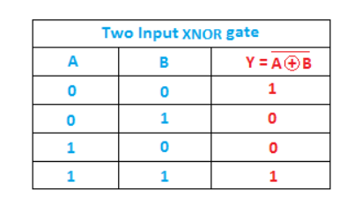

**CMOS technology: [invertor]**

**SCHEMATIC DAIGRAM:**

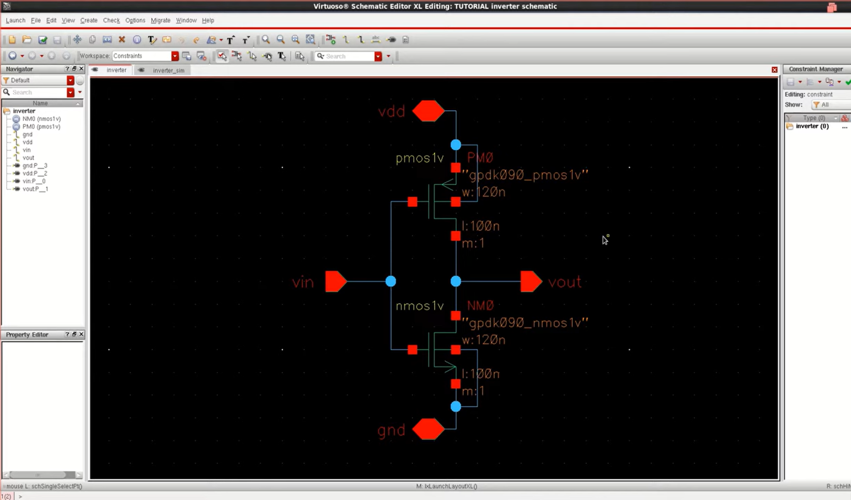

**TRANSIENT ANALYSIS:**

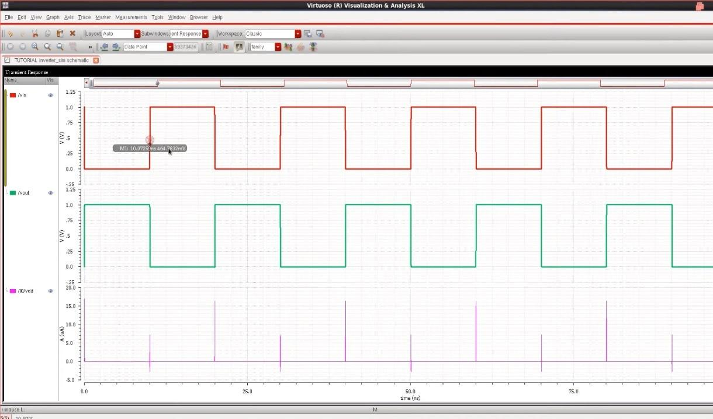

**CMOS Technology: [AND GATE]**

SCHEMATIC DAIGRAM:

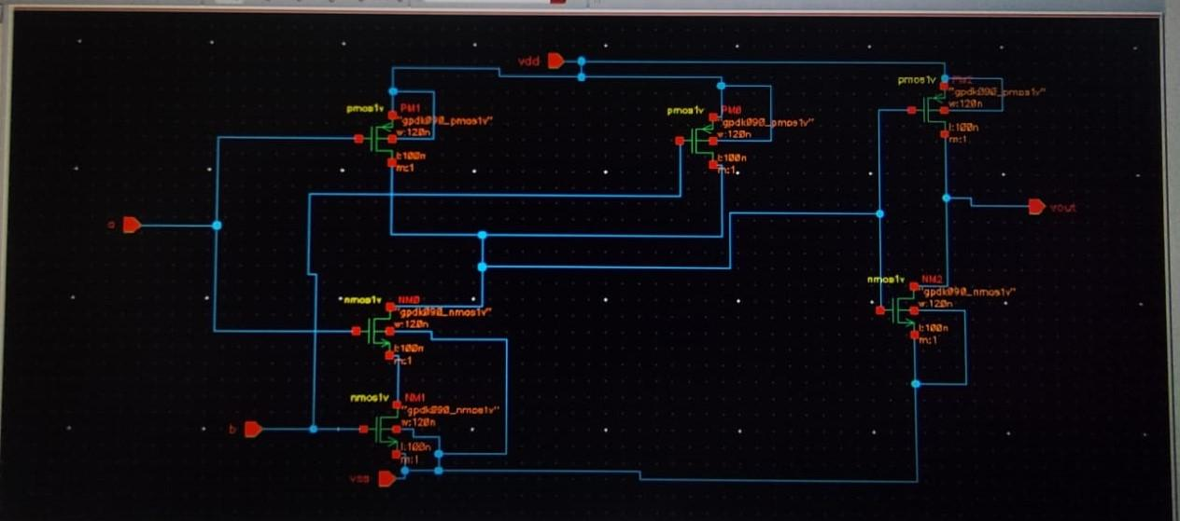

TRANSIENT ANALYSIS:

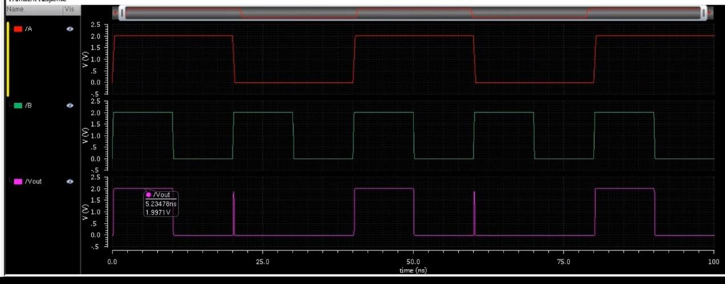

**CMOS Technology: [OR GATE]:**

SCHEMATIC DAIGRAM:

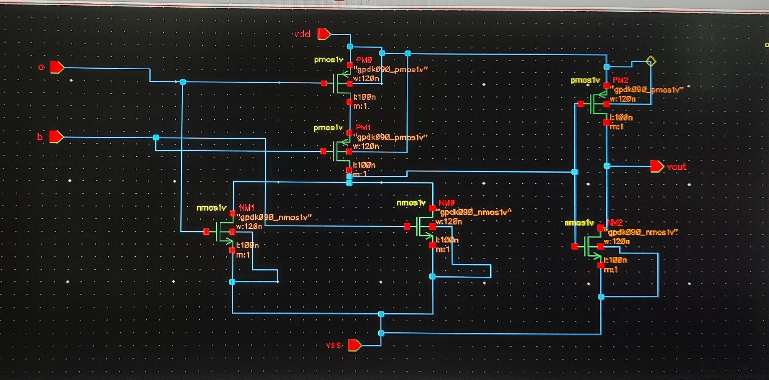

TRANSIENT ANALYSIS:

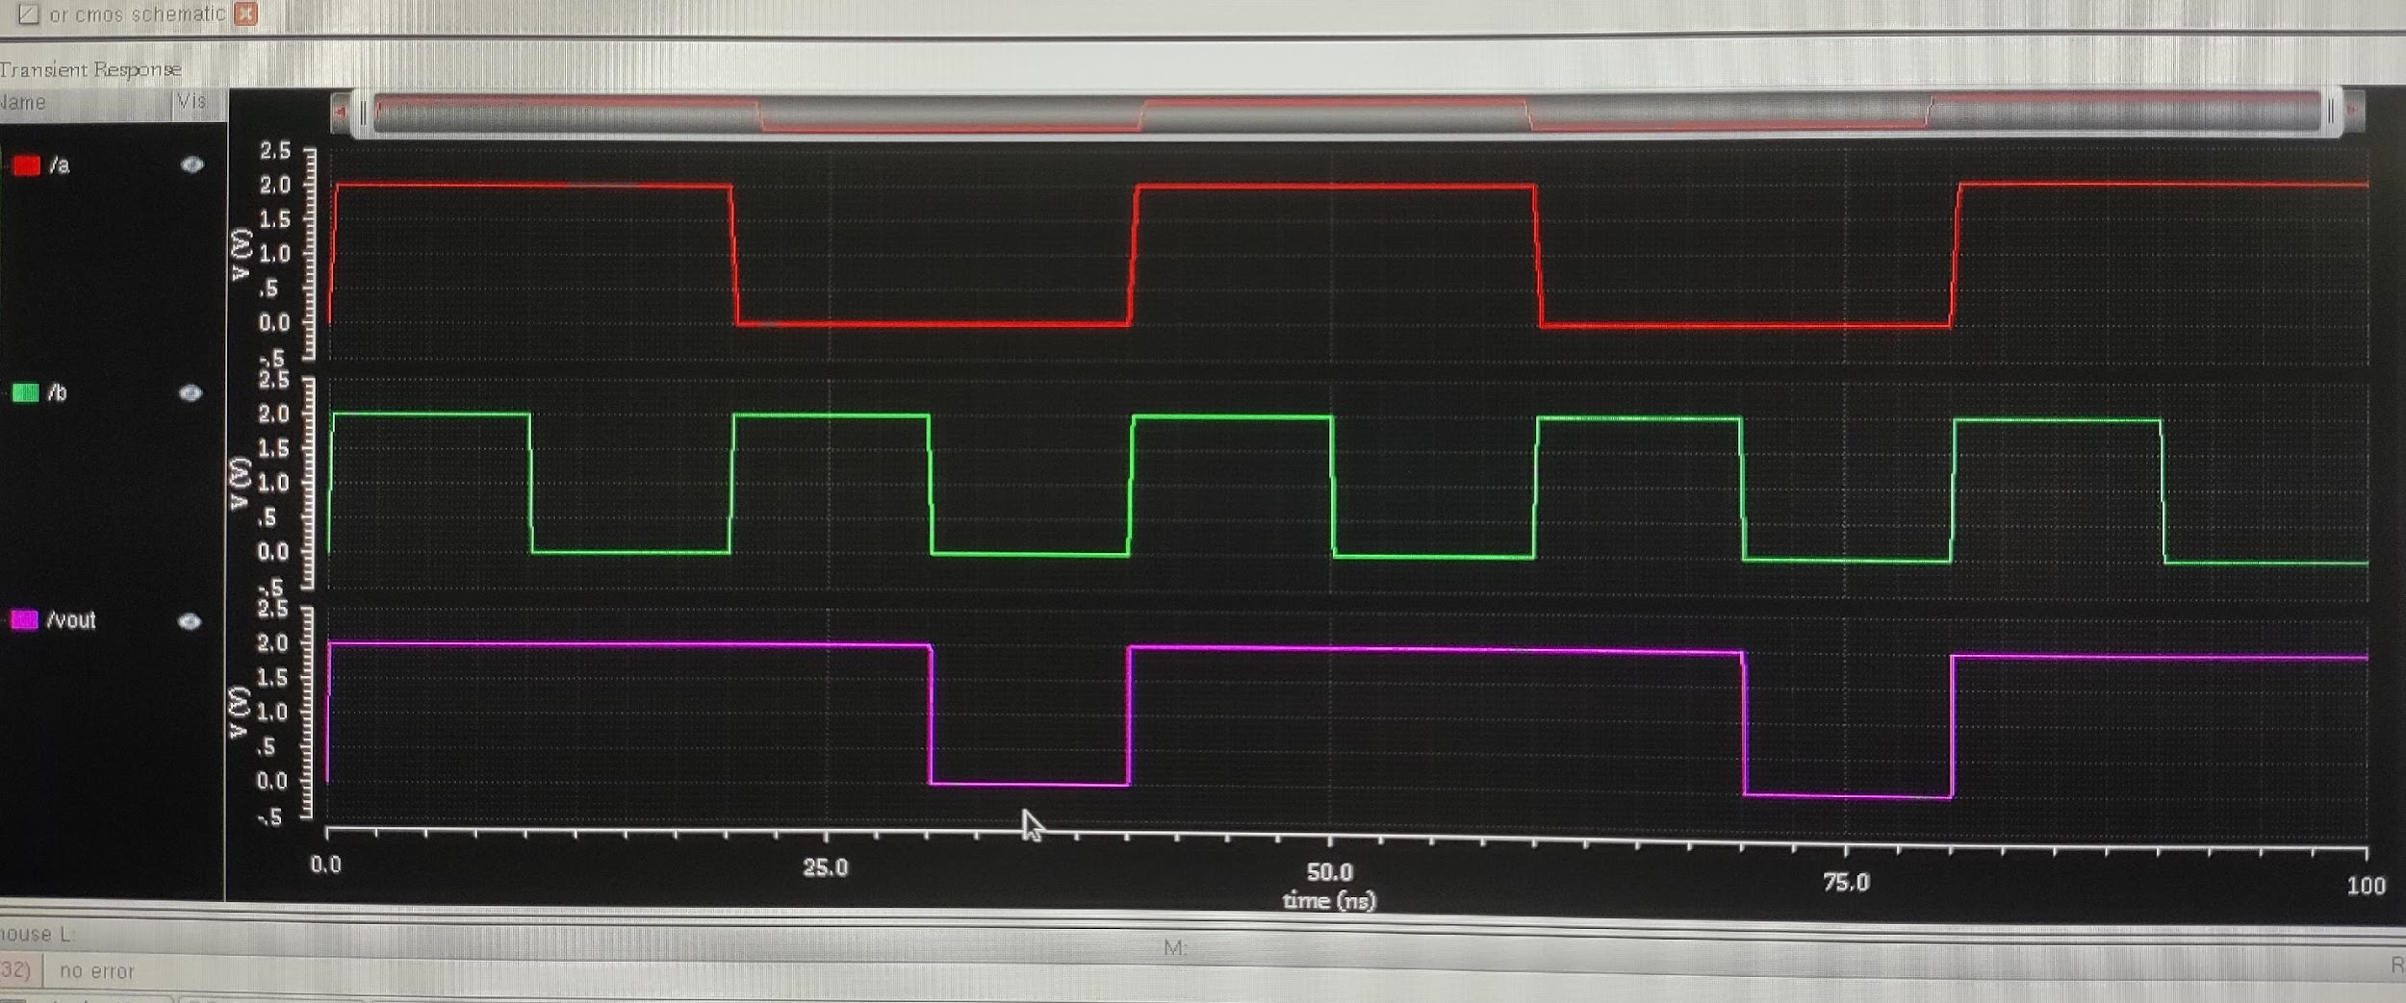

**CMOS Technology: [NAND GATE-active high]:**

SCHEMATIC DAIGRAM:

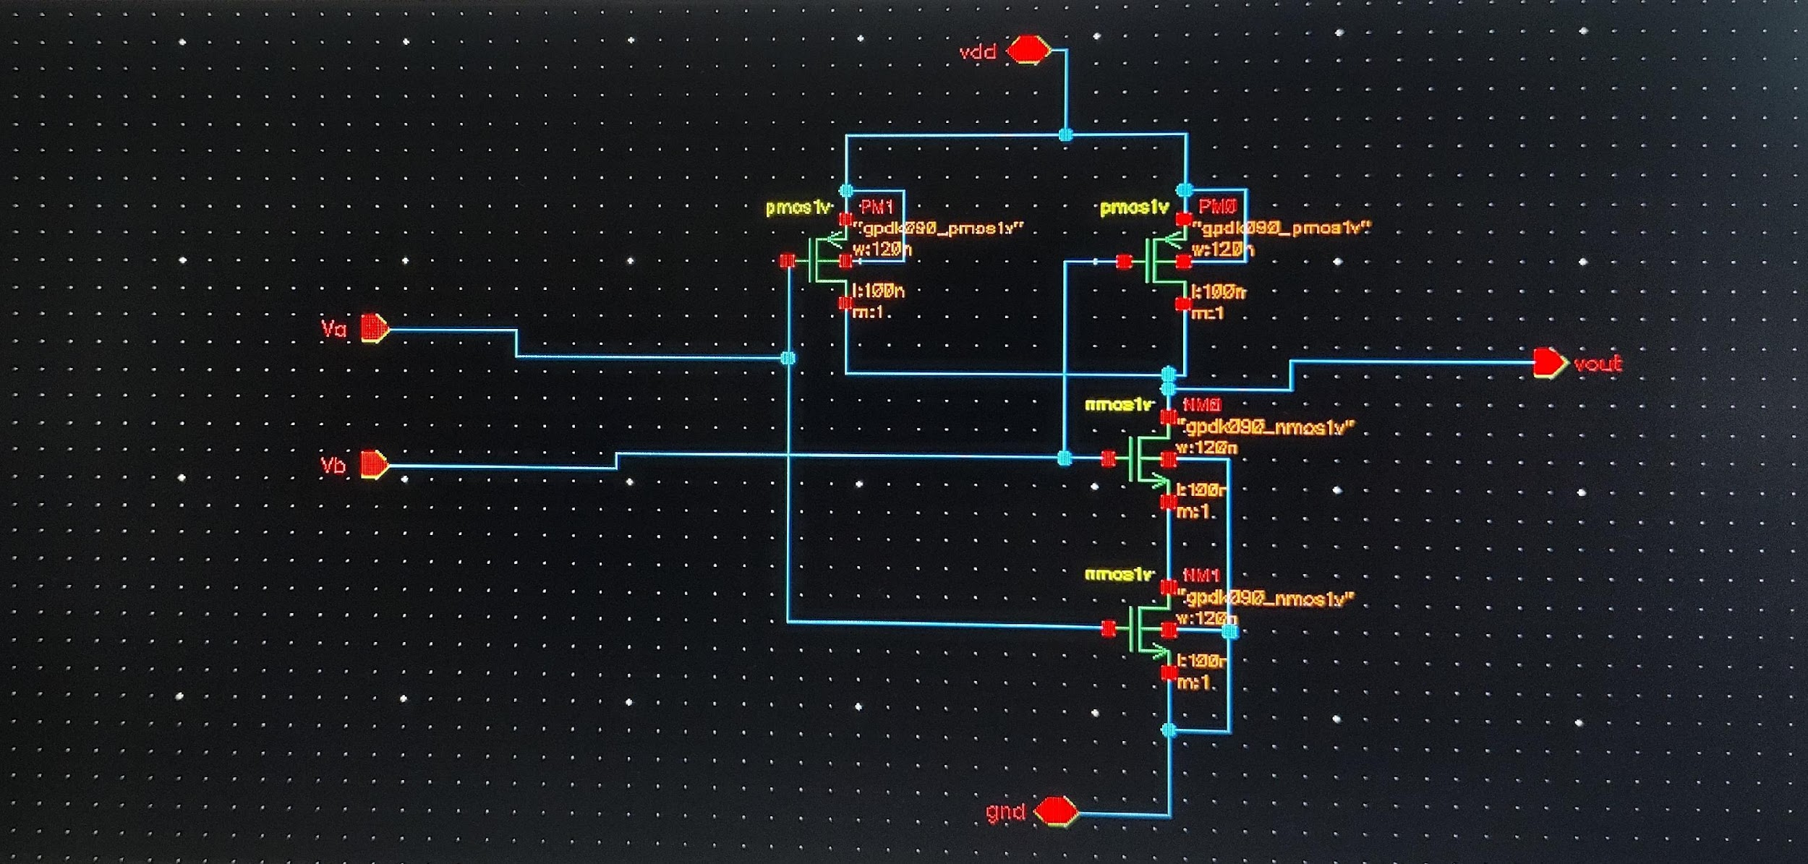

TRANSIENT ANALYSIS:

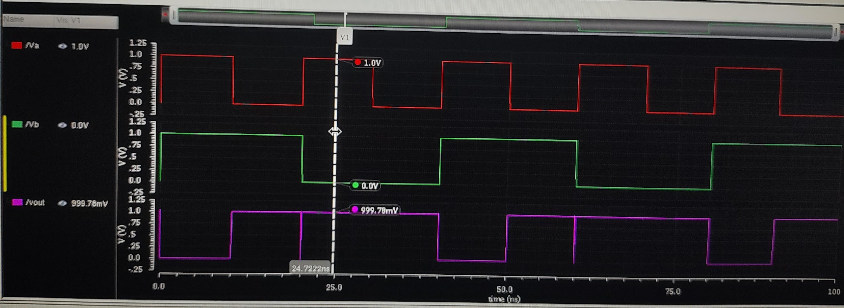

**CMOS Technology: [NOR GATE]:**

SCHEMATIC DAIGRAM:

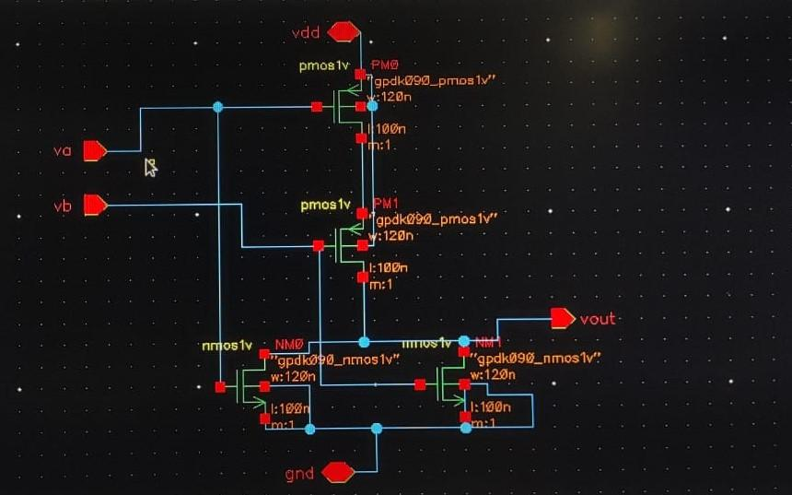

TRANSIENT ANALYSIS:

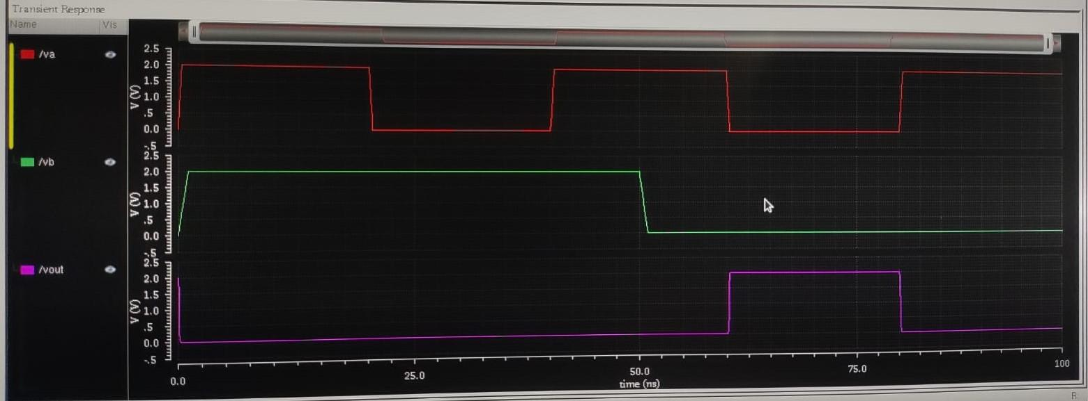

**CMOS Technology: [EX-OR GATE]:**

SCHEMATIC DAIGRAM:

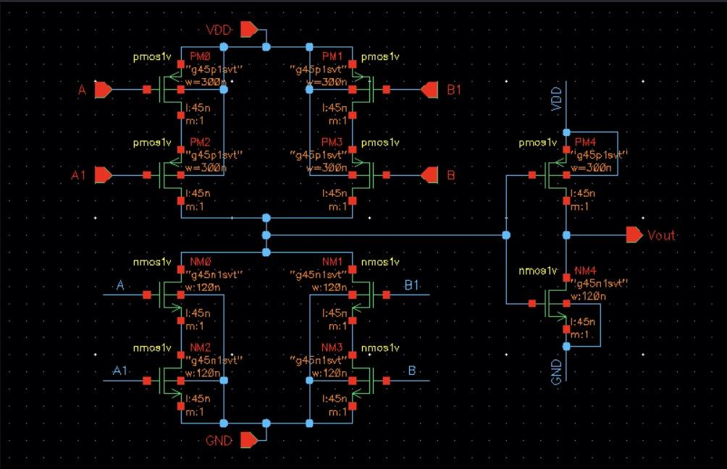

TRANSIENT ANALYSIS:

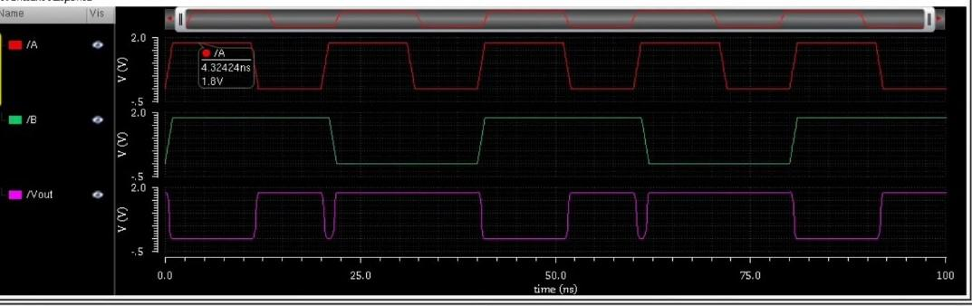

**CMOS Technology: [EX-NOR GATE]:**

SCHEMATIC DAIGRAM:

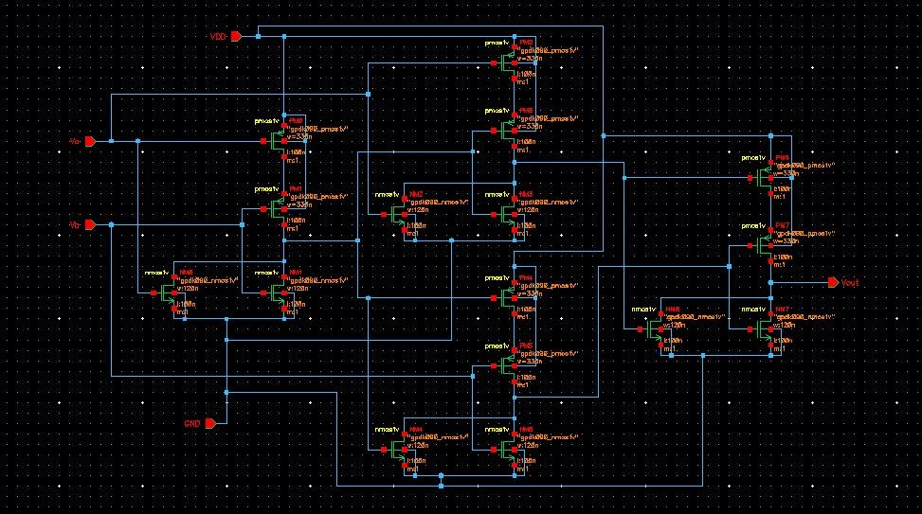

TRANSIENT ANALYSIS:

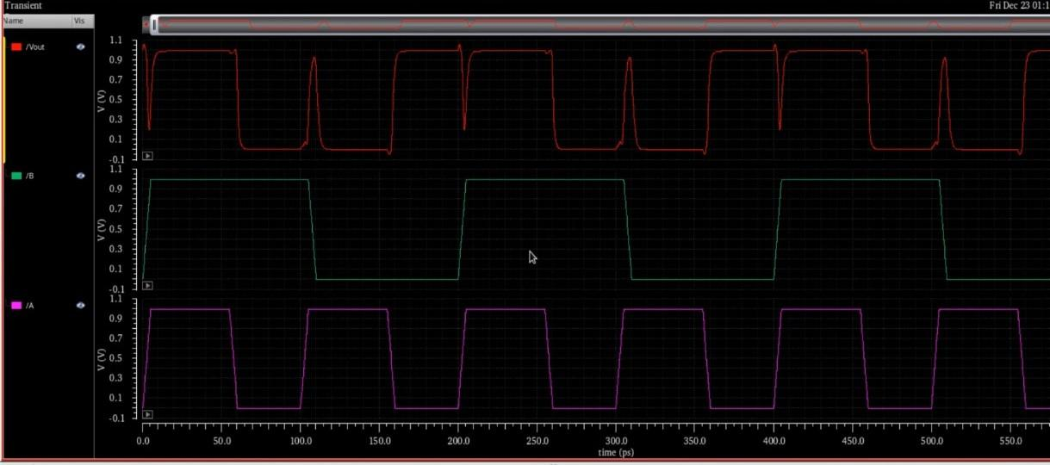

# **9.2 Flip-Flops (Memory)**

Flip-flops are **sequential logic circuits** that store **one bit of data** and are the building blocks of memory elements in digital systems. Unlike logic gates, **flip-flops have feedback loops** and depend on a clock signal for state changes.

**D-Flipflop:**

**Symbol:**

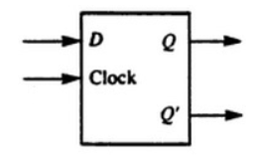

USING NAND:

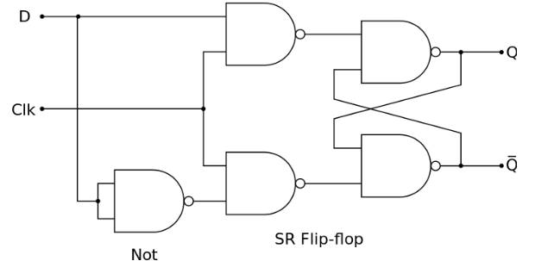

**Operation:** D = 0 → Q = 0 (Stores 0)

D = 1 → Q = 1 (Stores 1)

**Truth Table:**

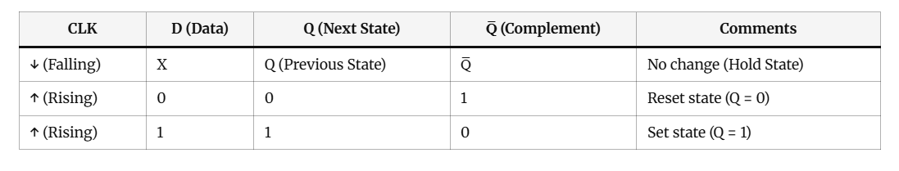

**SR-FLIPFLOP:**

**Symbol:**

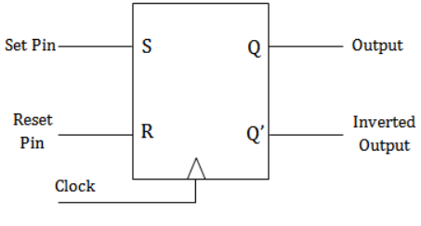

USING NAND:

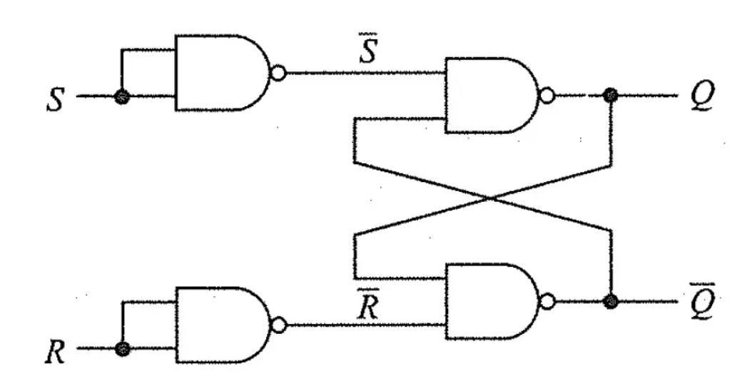

**Operation:** S = 1, R = 0 → Q = 1 (Set state)

S = 0, R = 1 → Q = 0 (Reset state)

S = 0, R = 0 → No change (Hold state)

S = 1, R = 1 → Invalid state (Not allowed in basic SR Flip-Flop)

**Truth Table:**

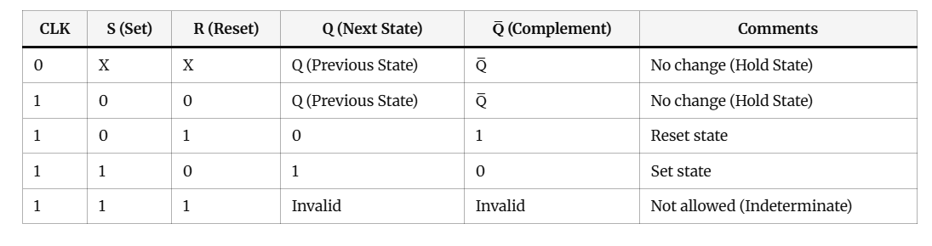

**JK FLIPFLOP:**

**Symbol:** 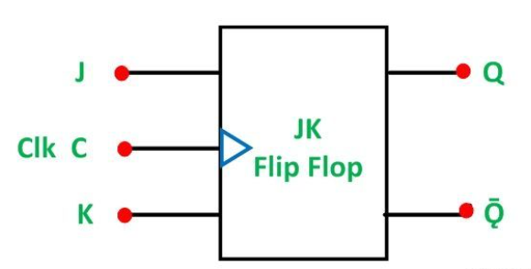

USING NAND:

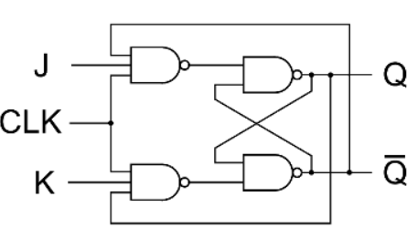

**Operation:** J = 0, K = 0 → No change (Hold state)

J = 0, K = 1 → Reset (Q = 0, Q̅ = 1)

J = 1, K = 0 → Set (Q = 1, Q̅ = 0)

J = 1, K = 1 → Toggle (Q changes state)

**Truth Table:**

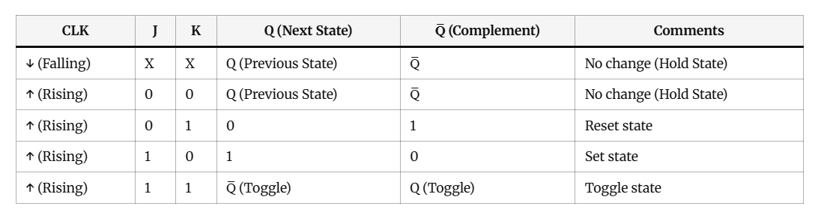

**T FLIPFLOP:**

**Symbol:**

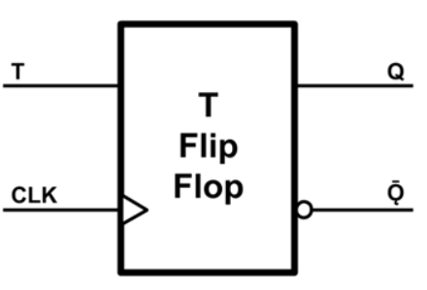

USING NAND:

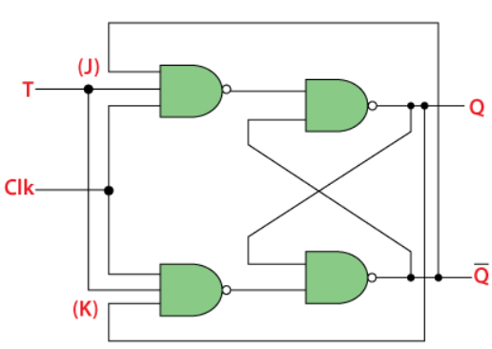

**Operation:** T = 0 → No change (Hold state)

T = 1 → Toggle (Q flips state)

**Truth Table:**

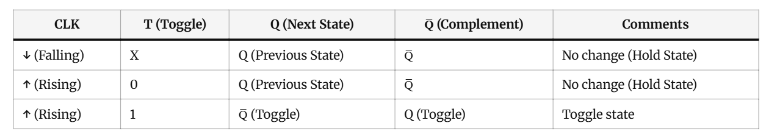

**SCHEMATICS:**

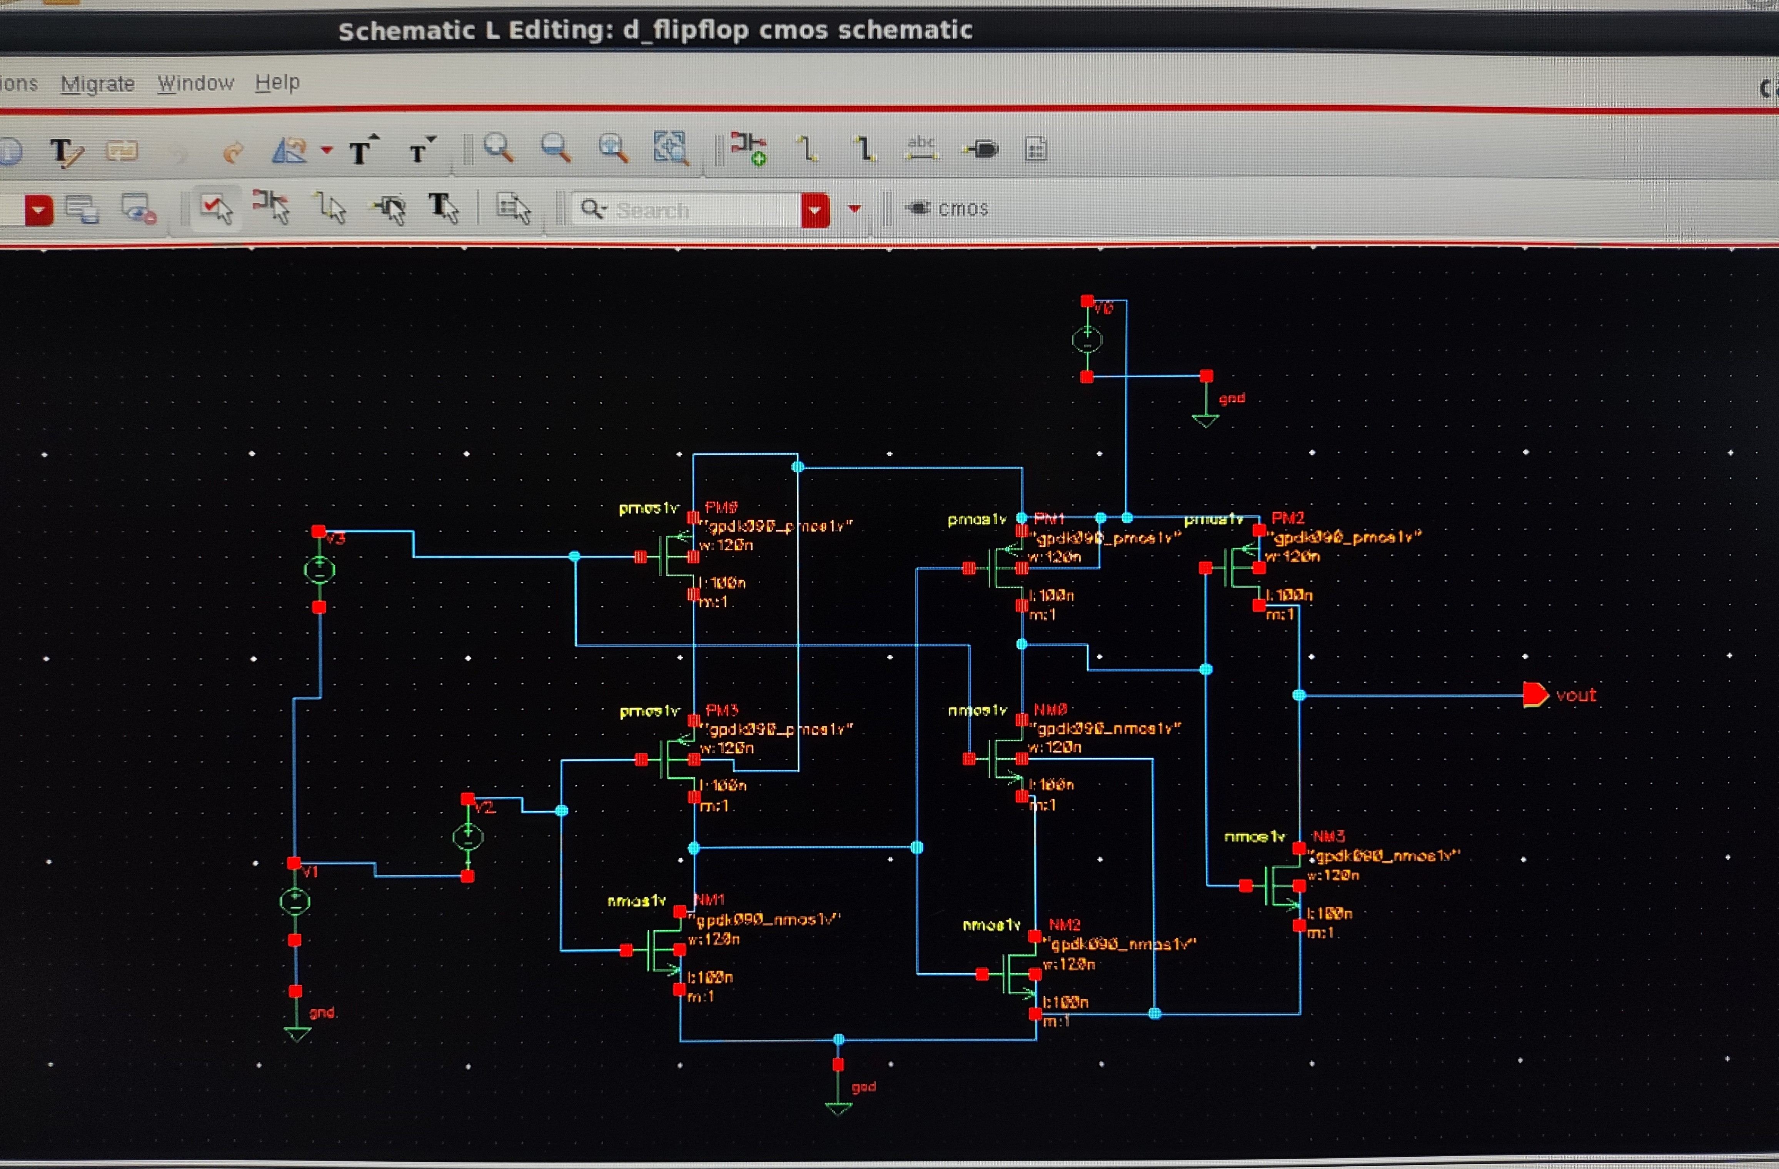

**T-Flipflop**

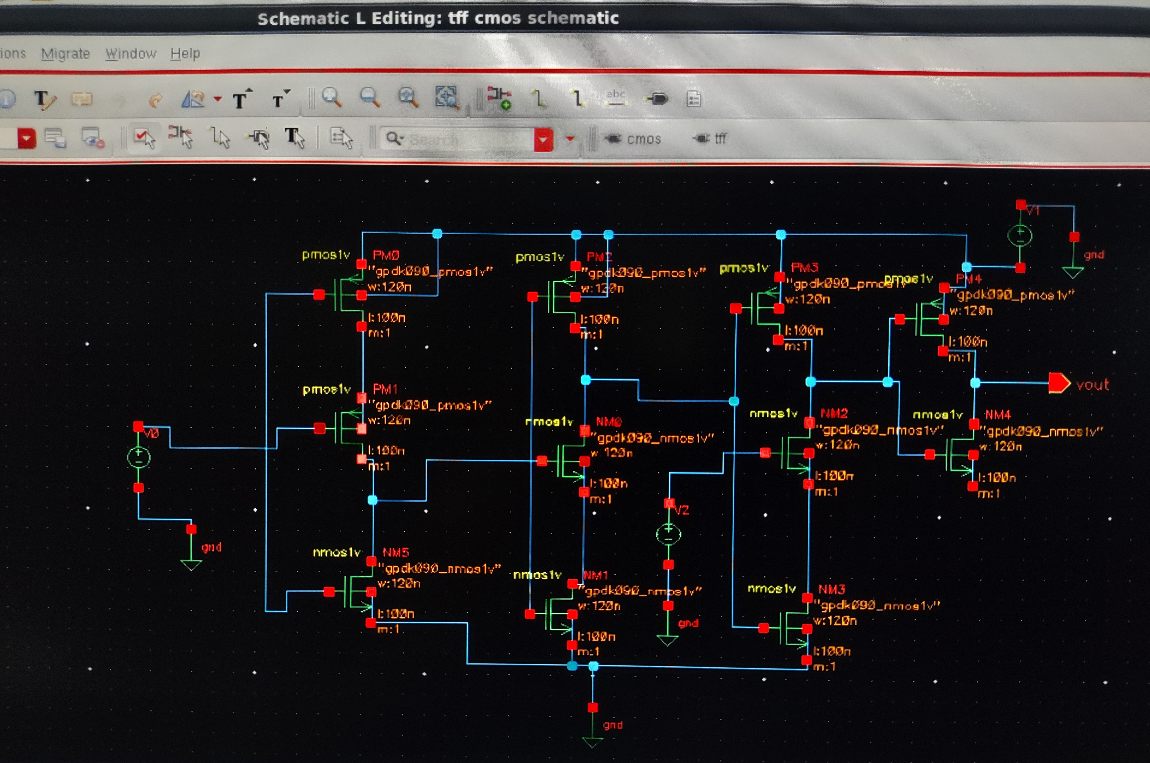

**SR-Flipflop**

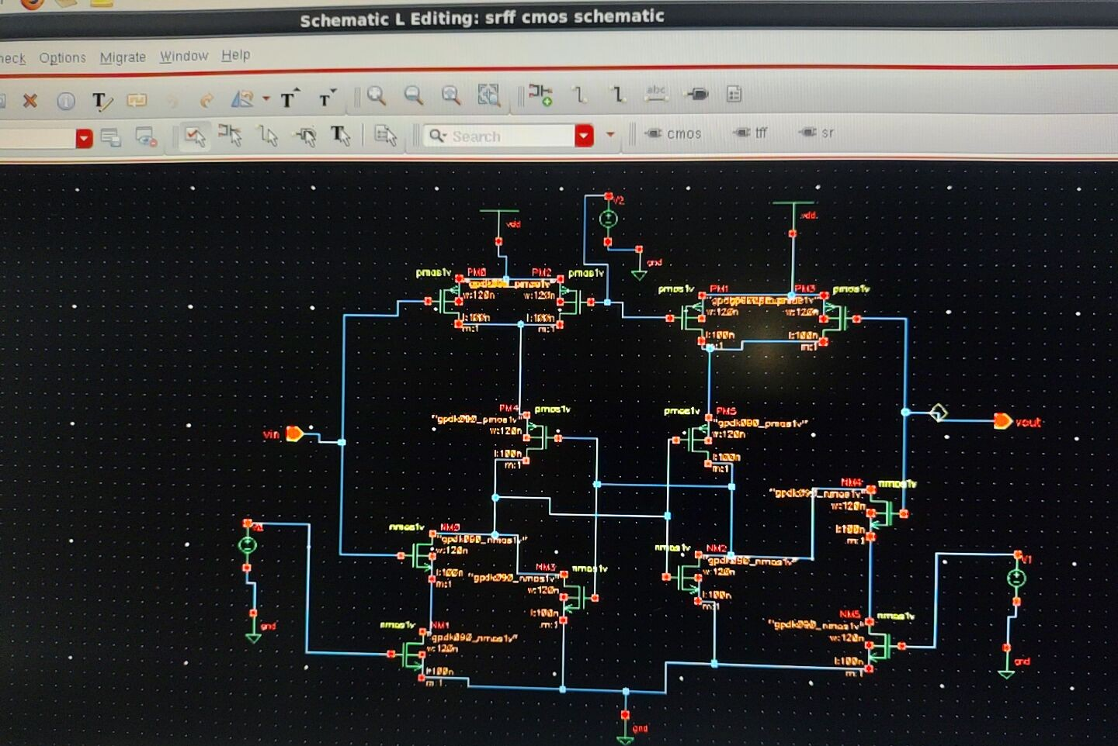

**JK-Flipflop**

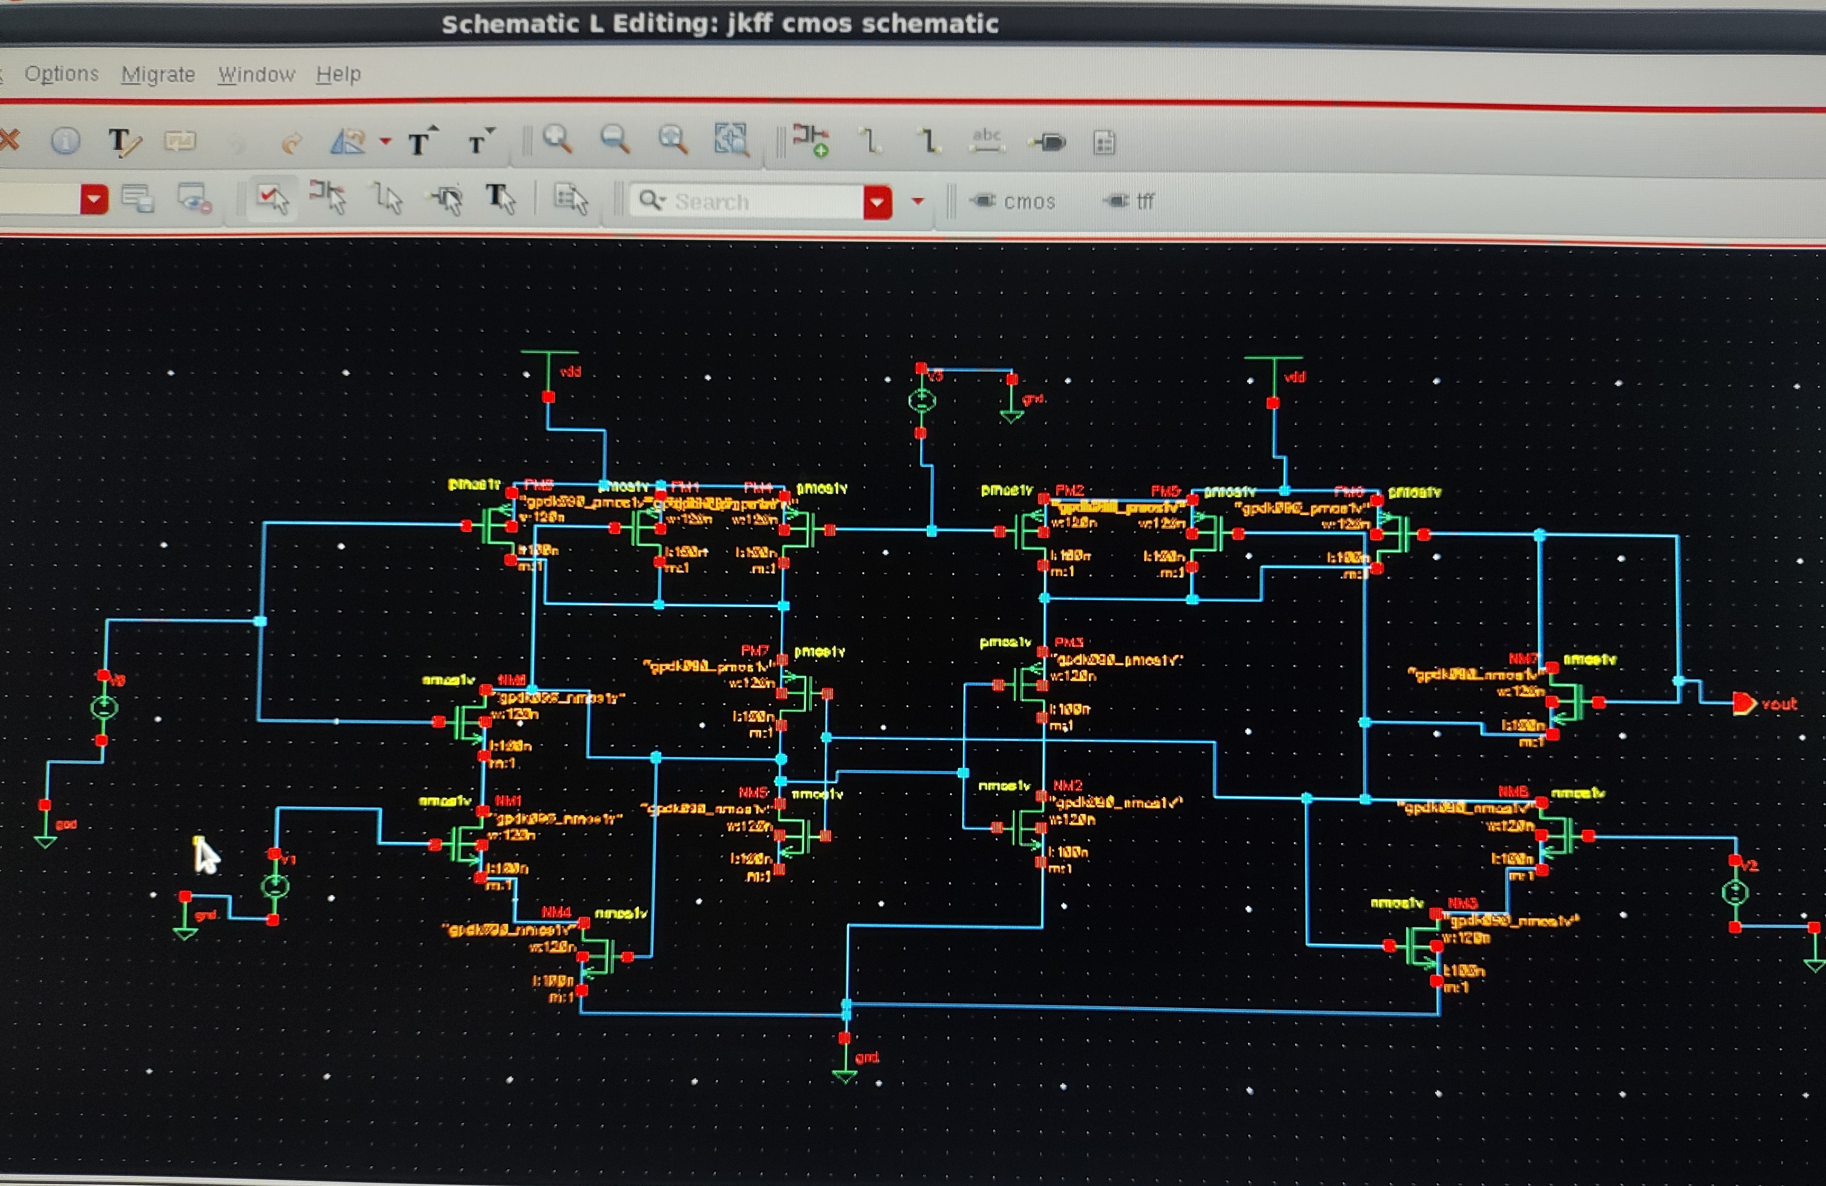

# **9.3 ALU**

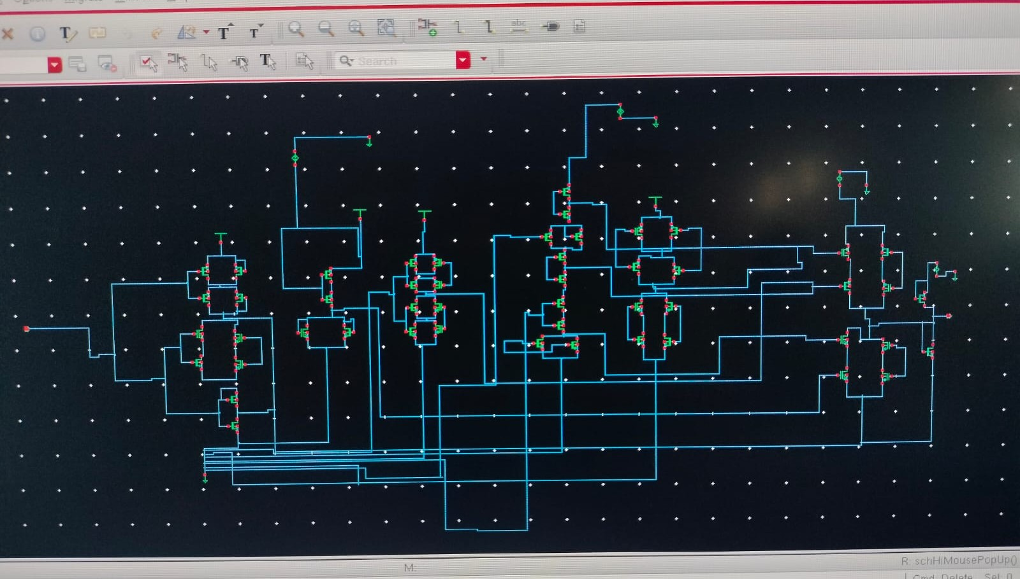

# **9.4 8-bit RISC processor using Xilinx Vivado**

RISC PROCESSOR

**VERILOG CODE:**

module risc1(

input clk, // Clock input

input rst, // Reset input

input [7:0] instruction, // 8-bit instruction input

output [7:0] result // 8-bit result output

);

// Internal signals

wire [7:0] reg1_data, reg2_data; // Data from registers

reg [7:0] alu_out; // ALU output (must be reg type)

wire zero_flag; // Zero flag from ALU

wire write_enable; // Enable writing to register file

wire [2:0] opcode; // ALU operation code

wire [2:0] reg1, reg2, reg_dest; // Register addresses

// Register File (8 registers, each 8 bits wide)

reg [7:0] registers [7:0]; // 8 registers, each 8 bits wide

// ALU Logic (Arithmetic Logic Unit)

always @(*) begin

case (opcode)

3'b000: alu_out = reg1_data + reg2_data; // ADD

3'b001: alu_out = reg1_data - reg2_data; // SUB

3'b010: alu_out = reg1_data & reg2_data; // AND

3'b011: alu_out = reg1_data | reg2_data; // OR

3'b100: alu_out = reg1_data; // MOV

default: alu_out = 8'b00000000; // Default to zero

endcase

end

// Zero Flag Logic (zero flag is 1 when ALU result is zero)

assign zero_flag = (alu_out == 8'b00000000) ? 1 : 0;

// Register File Read Logic (Read data from the registers)

assign reg1_data = registers[reg1]; // Read data from register 1

assign reg2_data = registers[reg2]; // Read data from register 2

// Instruction Decoding (Extract opcode and register addresses from the instruction)

assign opcode = instruction[7:5]; // Opcode is the upper 3 bits

assign reg1 = instruction[4:2]; // Register 1 is bits 4 to 2

assign reg2 = instruction[1:0]; // Register 2 is bits 1 to 0

assign reg_dest = instruction[4:2]; // Destination register (same as reg1 for now)

assign write_enable = 1'b1; // Always enable write (simplified control)

// Register File Write Logic (Write ALU output to the destination register)

always @(posedge clk or posedge rst) begin

if (rst) begin

// Reset all registers to 0 on reset signal

registers[0] <= 8'd0;

registers[1] <= 8'd0;

registers[2] <= 8'd0;

registers[3] <= 8'd0;

registers[4] <= 8'd0;

registers[5] <= 8'd0;

registers[6] <= 8'd0;

registers[7] <= 8'd0;

end else if (write_enable) begin

// Write ALU output to the destination register

registers[reg_dest] <= alu_out;

end

end

// Final result output (assign ALU output to result)

assign result = alu_out;

endmodule

**SCHEMATIC DESIGN:**

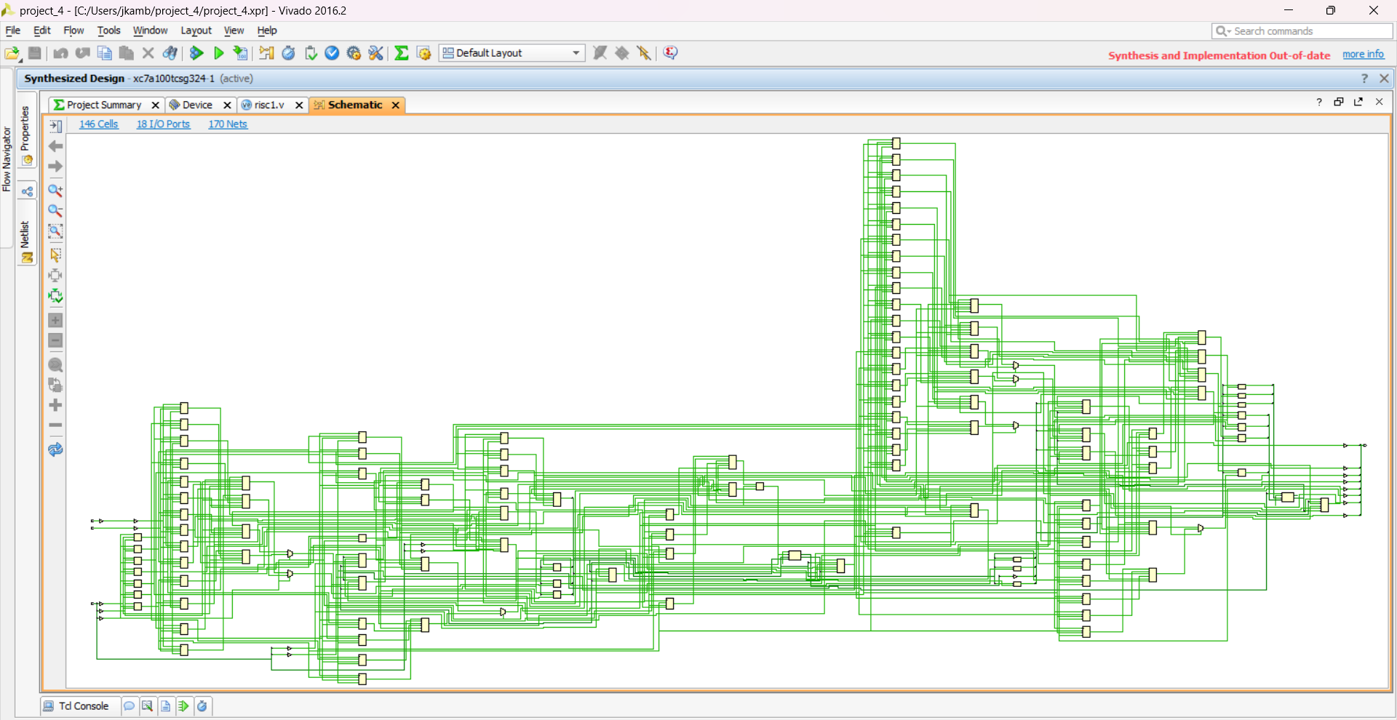

**SYNTHESIZED DESIGN:**

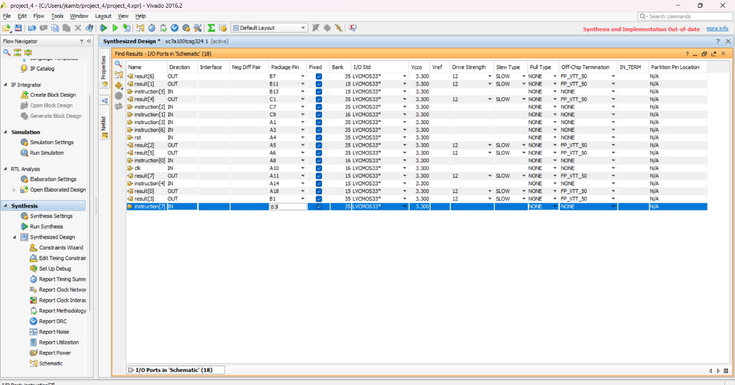

# **Chapter 10: Results**

# **10.1 BJT parameters**

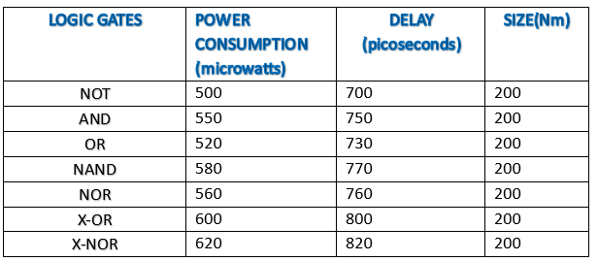

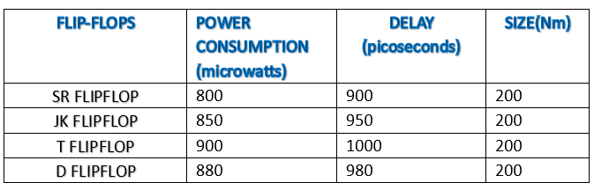

# **10.2 BASIC MOSFET parameters**

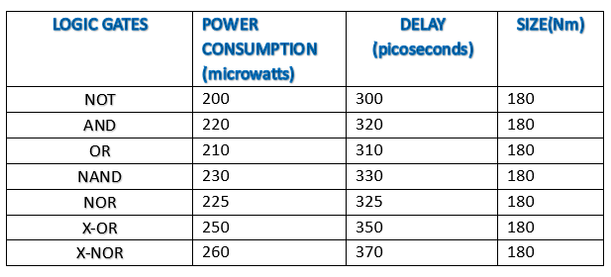

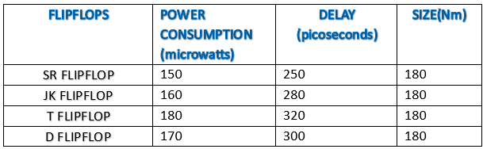

# **10.3 CMOS parameters**

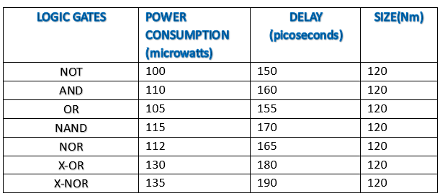

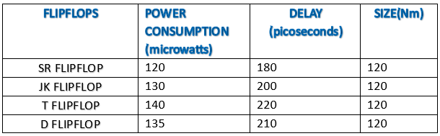

# **Chapter 11: Conclusion**

* **RISC Processor in Verilog (Xilinx Vivado):** This method uses coding (Verilog) to design a processor, which can be tested and run on an FPGA. It is faster and easier since you work with digital logic instead of individual transistors.
* **Building with Transistors (Cadence CMOS/BJT/MOSFET):** This approach designs the processor at the transistor level, using CMOS, BJT, MOSFET. It gives more control over power and performance but is much harder and takes more time.
* Our project aims to design a microprocessor by studying and integrating analog, digital, and mixed-signal systems using advanced semiconductor technologies such as BJT, CMOS, and MOSFET.
* The focus is on leveraging the unique characteristics and strengths of each technology to optimize the performance, power consumption, area, and delay of the microprocessor.

# **Chapter 12: Future Work**

* This future work plan outlines the key steps and considerations involved in designing a microprocessor using ALU, flip-flops, and gates using FINFET technology
* By following this plan, we aim to develop a high-performance and reliable microprocessor that meets the specific requirements of our project.

# **Chapter 13: References**

[1] COMPARATIVE STUDY OF FINFET WITH MOSFET AND CMOSFET. International Journal of Management, Technology And Engineering - ISSN NO : 2249-7455.

[2] Design Steps, Simulation, and Analysis of a 1-bit ALU in Cadence at 90 nm CMOS Node. IOSR Journal Of VLSI And Signal Processing (IOSR-JVSP) Volume 13, Issue 6 (Nov. - Dec. 2023), Pp.01-14 E-ISSN: 2319-4200, P-ISSN: 2319-4197 .

[3] Comparative Analysis of FINFETS and MOSFETS.

[4] Cadence Virtuoso Schematic Design and Circuit Simulation Tutorial

[5] International Journal of Management, Technology And Engineering ISSN NO : 2249-7455 COMPARATIVE STUDY OF FINFET WITH MOSFET AND CMOSFET

[6] M. H. Bhuyan, F. Ferdous, And Q. D. M. Khosru, “A Threshold Voltage Model For Sub-100 Nm Pocket Implanted Nmosfet,” Proceedings Of The Ieee Sponsored International Conference On Electrical And Computer Engineering, Bangladesh University Of Engineering And Technology (Buet), Dhaka, Bangladesh, 19-21 December 2006, Pp. 522-525.

[7] M. H. Bhuyan And Q. D. M. Khosru, “Low Frequency Drain Current Flicker Noise Model For Pocket Implanted Nano Scale N Mosfet,” Proceedings Of The Ieee And Eds Sponsored Nano Materials And Device Conference (Nmdc), 12-15 October 2010, Monterey, Ca, Usa, Pp. 295-299.

[8] [1] B. Rajesh Kumar, Ravisaketh and Santha Kumar, 2014, “Implementation of A 16-bit RISC Processor for Convolution Application”, Research India publications, pp 441-446.

[9] 2]. Hamblen J.“ Synthesis, Simulation, and Hardware Emulation to Prototype a Pipelined RISC Computer System”

[10] Virendra S. and Michiko I,“Instruction-Based SelfTesting of Delay Faults in Pipelined Processors”, IEEE Transaction on VLSI systems, vol. 14, no.11,pp.1203-1215.

[11] Patterson A. and Hennessy J,“Computer Organization & Design”, Morgan Kaufmann Publishers, 1999 [8].

[12] Peter J Ashenden,“Digital Design, An embedded systems approach using Verilog”, Morgan Kaufmann Publishers,2010 .

[13] Ramesh Gaonkar,“Microprocessor architecture, programming and applications with the 8085”, Penram International Publishing,1989.

[14] Comparative Analysis of FINFETS and MOSFETS To cite this article: Chen Shao 2021 J. Phys.: Conf. Ser. 1887 012033

[15] Aditya waingankar et all.,2016,”Logic Circuits using FinFET: Comparative Analysis” IJSRD, National Conference on Technological Advancement and Automatization in Engineering, January 2016 ISSN:2321-0613 .

[16] Anshul Jain et al.,2014, “ Optimization of Leakage Current and Leakage Power of FinFET Based 6T SRAM Cell” Inte rnational Journal of Engineering Technology, Management and Applied Sciences, August 2014, Volume 2 Issue 3, ISSN 2349-4476 . [17]Bazizi.E.M et al.,2015, “Advanced TCADSimulation of Local Mismatch in 14nm CMOS Technology FinFET’s” SISPAD 2015, September 9-11, 2015, Washington, DC, USA